**Question 1.1:**

1. My student number is **71571**. So I marked the packet with segment number **71**. As can be seen from the 3rd screenshot my segments TTL value is: **64**. TTL short for Time to Live is a maximum amount of time/hops the packet is allowed to live or traverse through network. It is a mechanism to control the lifespan and reach of network packets and if it reaches 0 before packet is arriving to a destination the packet is dropped and error message is sent. TTL helps prevent packets from circulating indefinitely in a network due to routing errors or other issues.

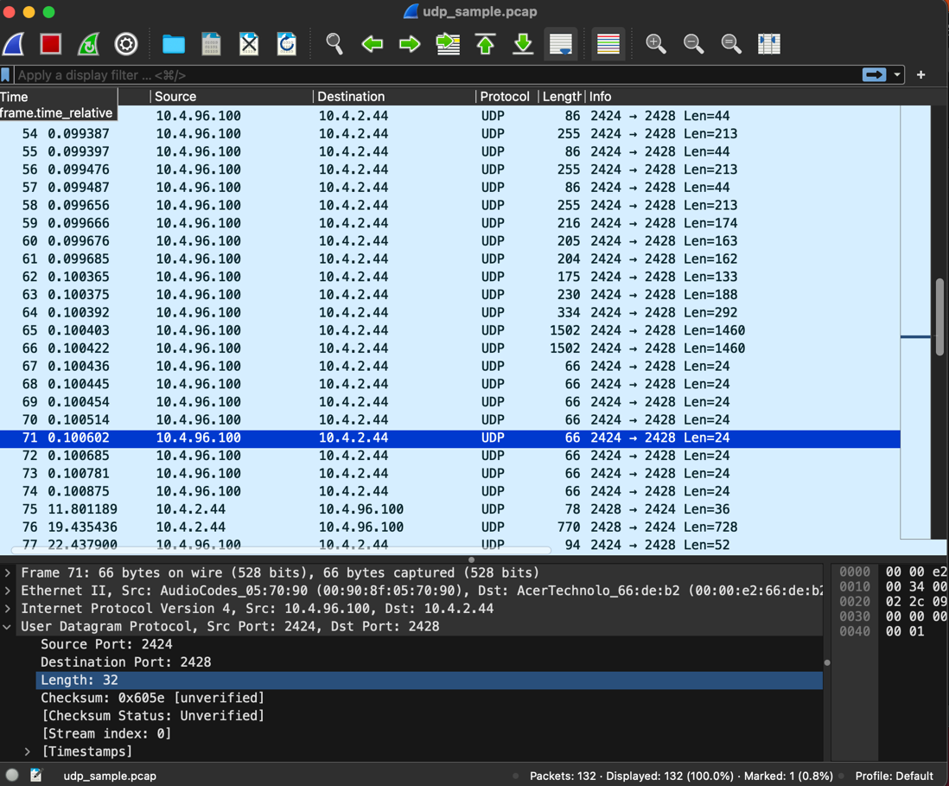

*Fig1*

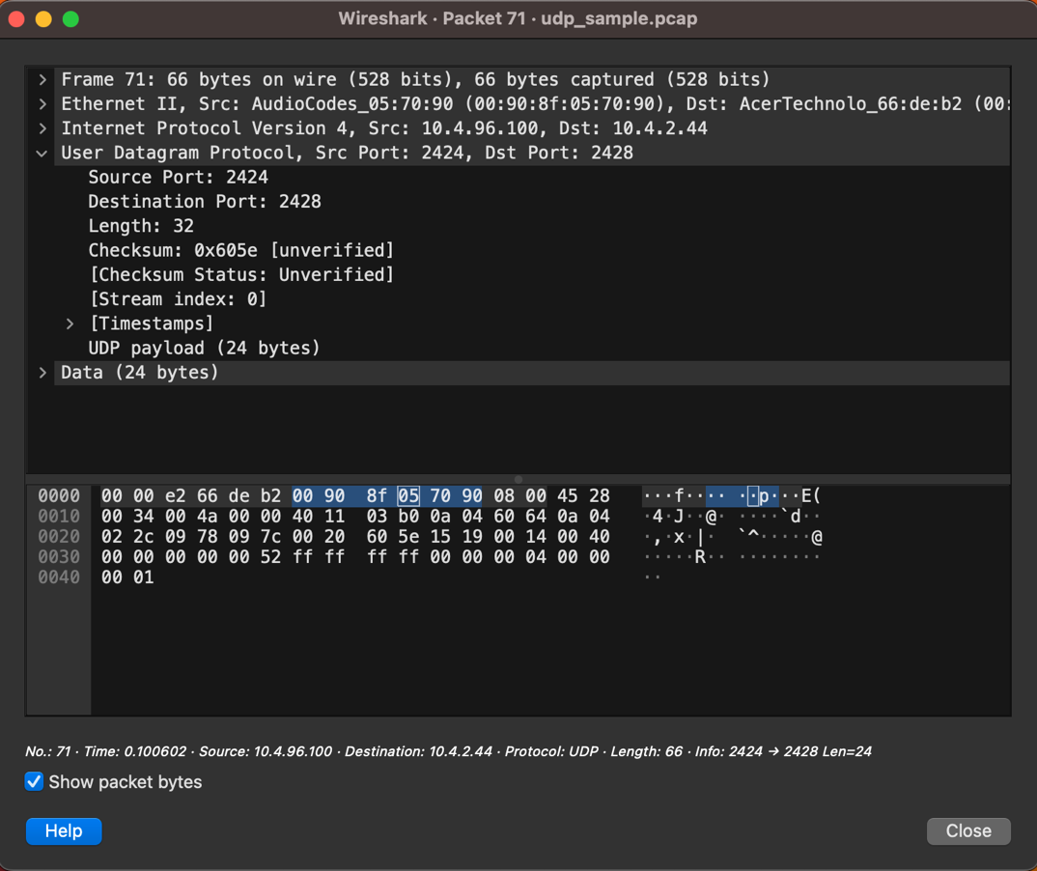

*Fig2*

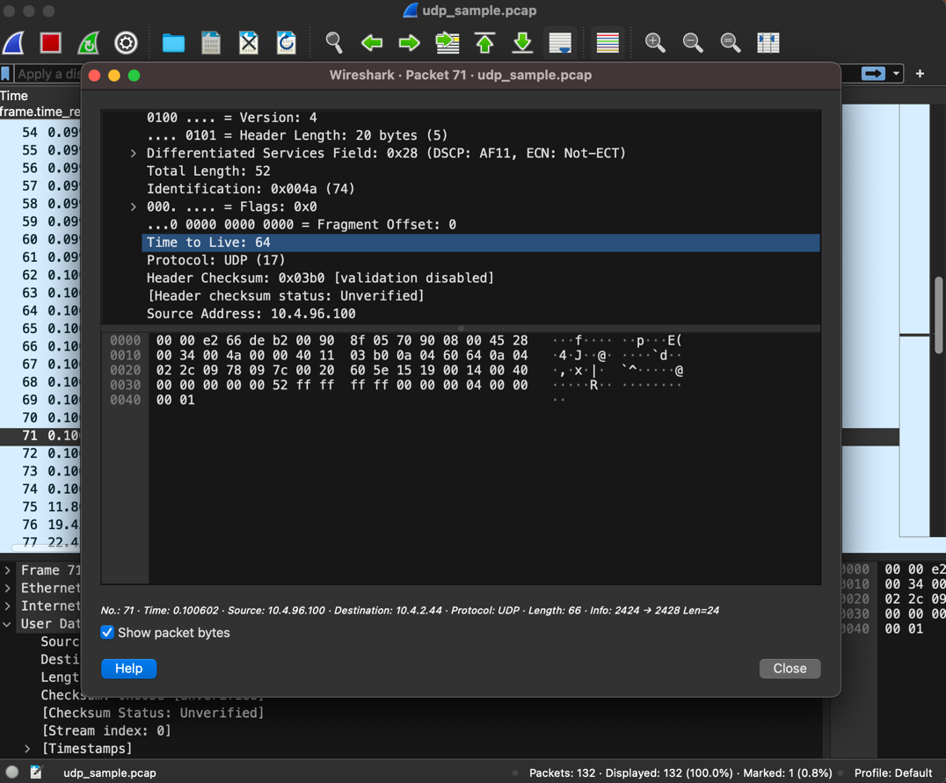

*Fig3*

1. As can be seen from the below screenshots my segment’s stream index is 0. The stream index for a UDP segment represents the numbering of conversations associated with TCP and UDP socket pairs. The calculations for TCP and UDP are done independently. The first conversation is assigned the stream index 0, the second conversation gets index 1, and so on.

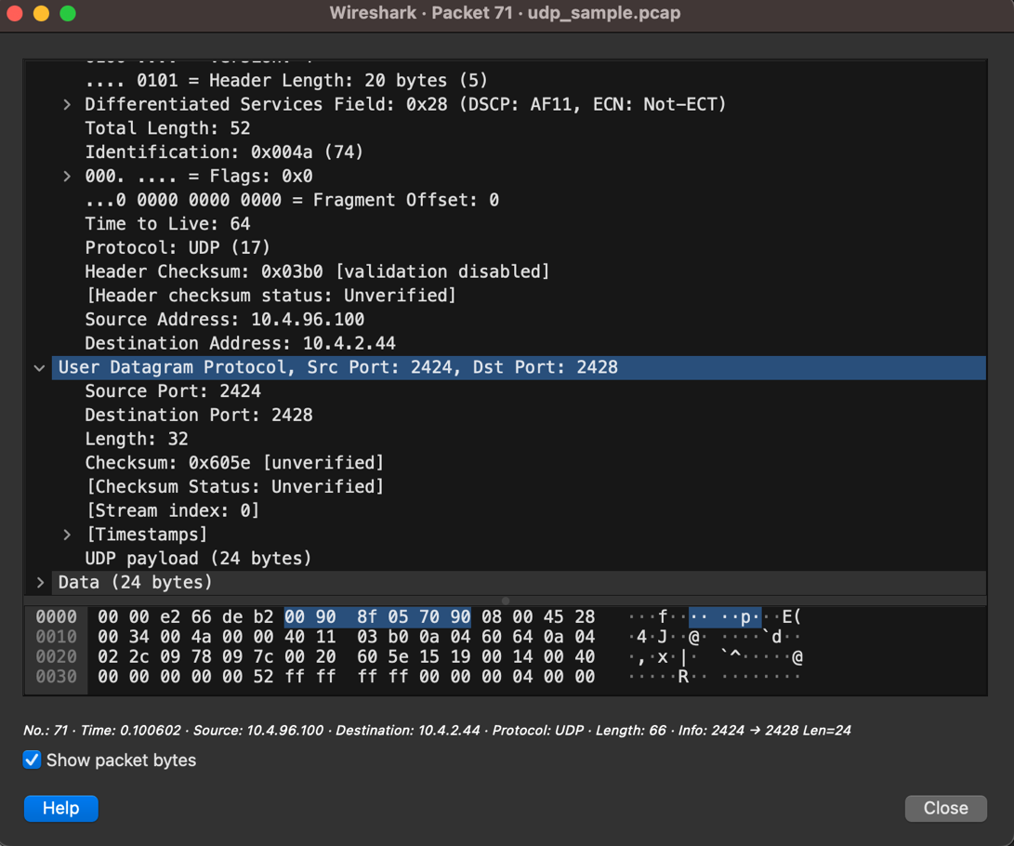

*Fig1*

1. Checksum value of the segment can be seen in the below screenshot. It is **0x605e(24670)** in the UDP header**.** Checksum is a mechanism to check the corruption of the packet, detect errors throughout its transmission. It is calculated by treating contents of UDP/TCP segment as sequence of 16 bit integers and adding all of them. It is present both on UDP and TCP. Main difference between them is while in TCP if checksum resulted different in server and client side, protocol retransmits the packet, in UDP retransmission is not done. Based on the application client may decide to use the packet which has error or discard it.

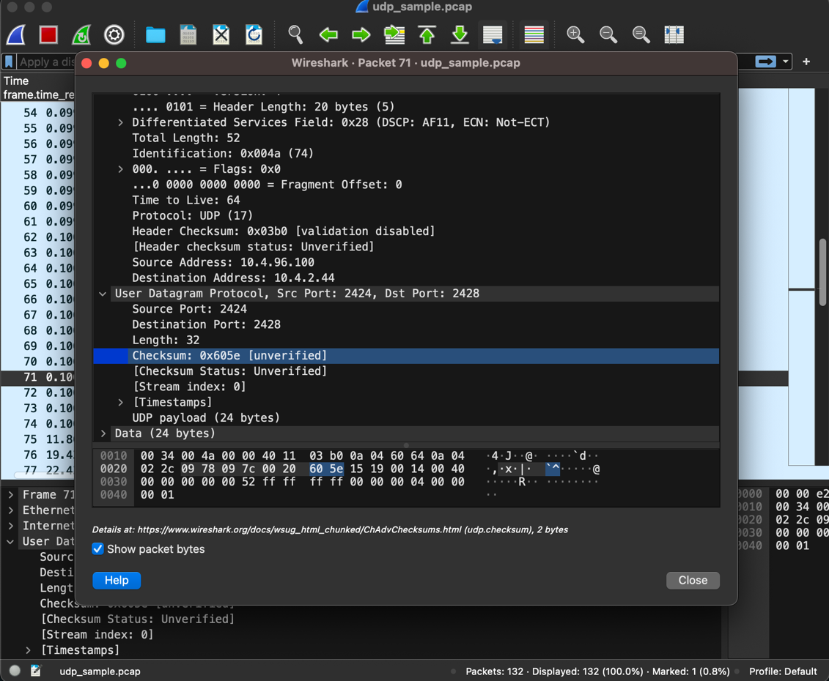

*Fig1*

1. As can be seen from the below screenshot reserved bit is 0. The IP v4 header has three flags: the reserved bit, the don't fragment bit, and the more fragments bit.

The least important bit in the Flags field is the reserved bit, or bit 0.

If set, the Don't Fragment (DF) bit (bit 1) denotes that the packet shouldn't be broken up while being transmitted. The More Fragments (MF) bit (bit 2), if set, indicates that there are more fragments to come and that the packet is a part of a fragmented collection of packets. In the current IPv4 specification, the Reserved bit is set aside for possible future usage and has no defined use. Devices processing IPv4 packets should always set it to 0 and ignore it.

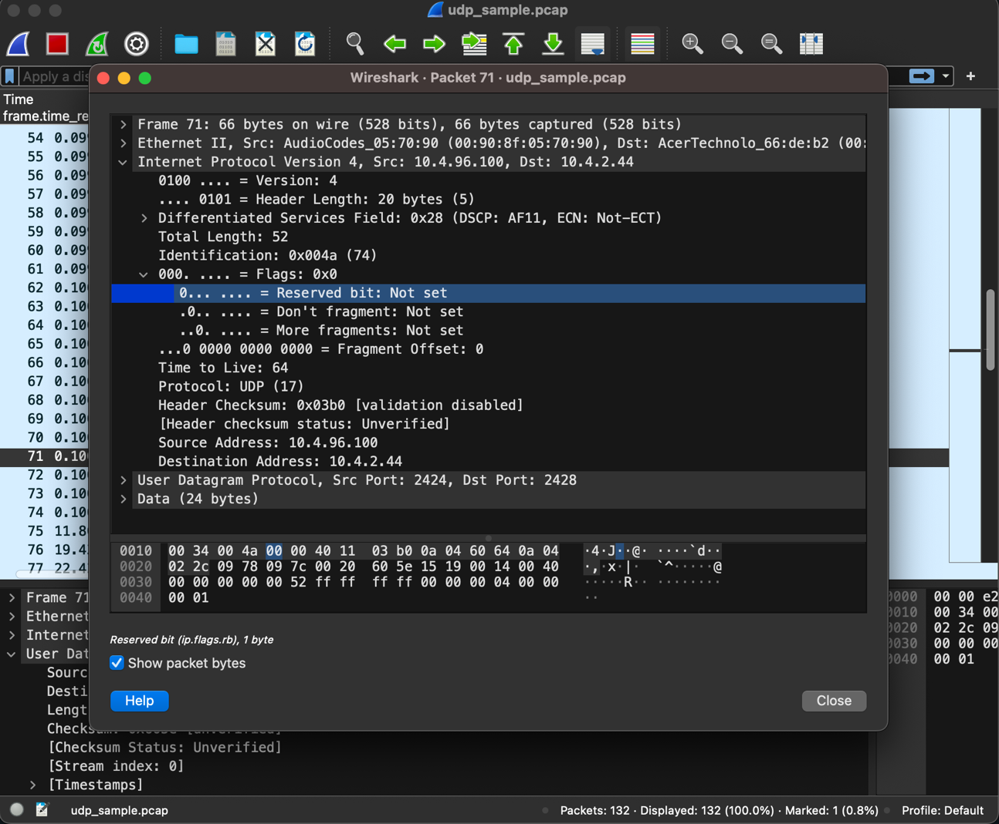

*Fig1*

1. The total length of the frame is 66 bytes incluuding header and data. The total length of UDP is 32 and UDP payload is 24 . You can see both of them in below.

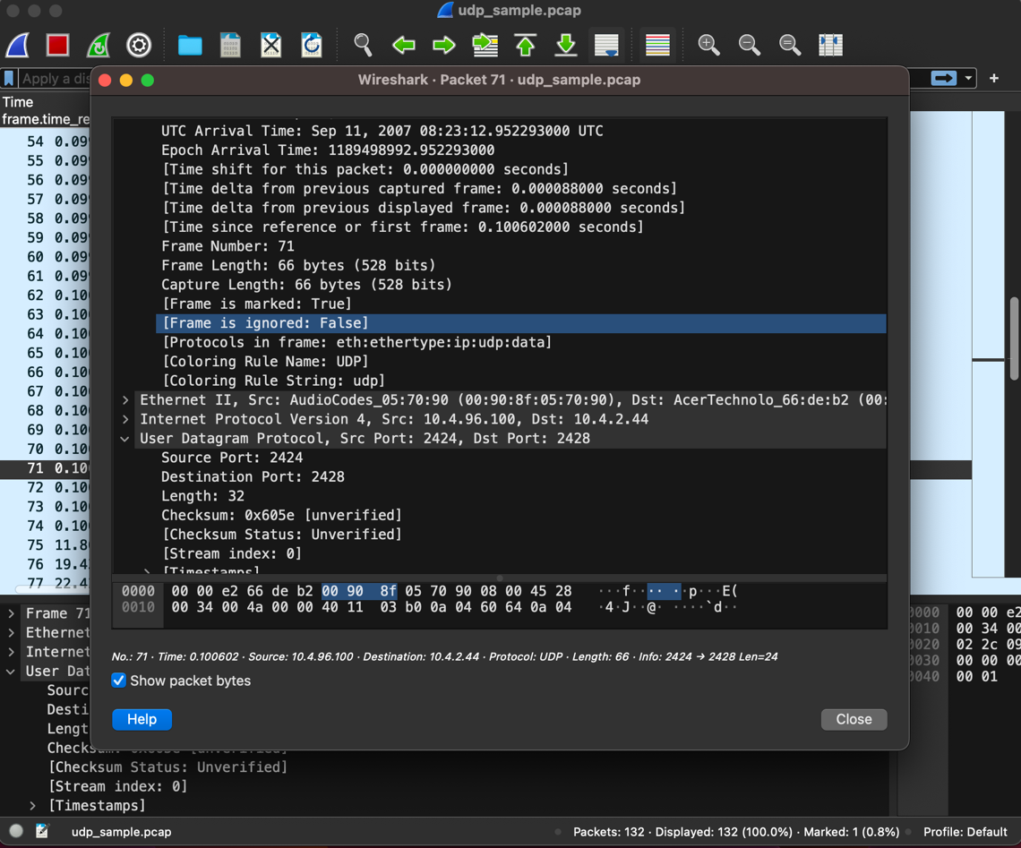

*Fig1*

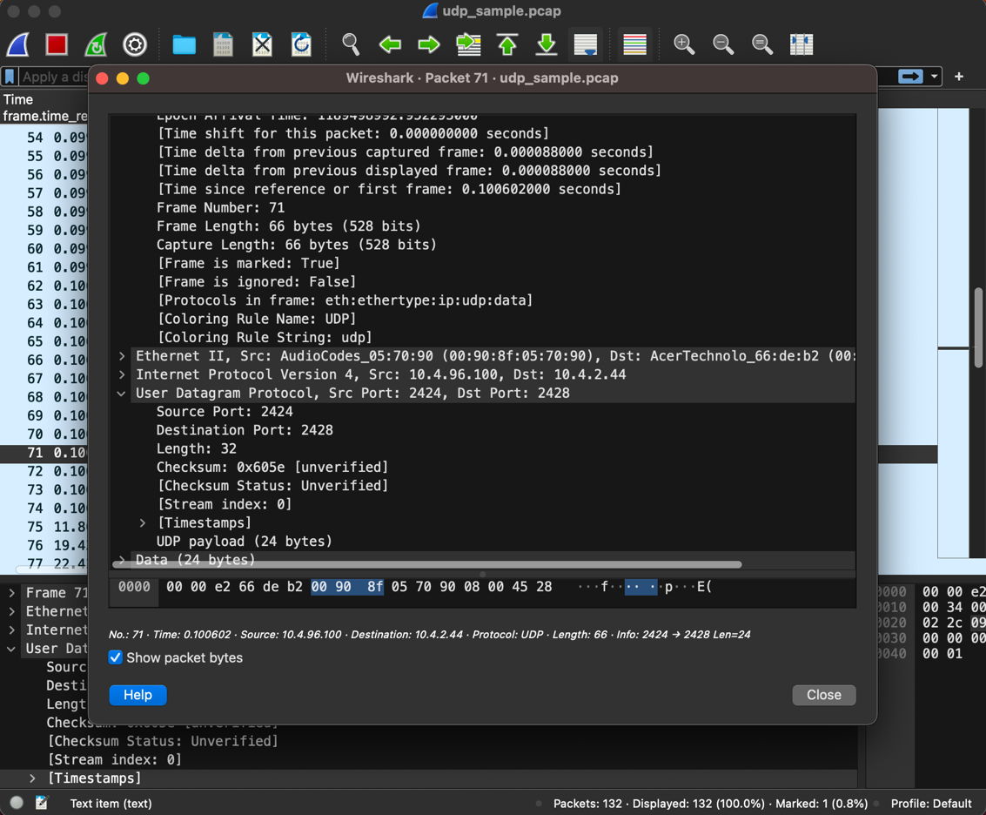

*Fig2*

**Question 1.2:**

1. From the first screenshots it can be seen that there are 2 TCP retransmissions. To verify that we can check the source and destination in TCP retranssmission and http post request which can be seen in the 2nd screenshot, they are the same. Srcport: 52790 and dst port is 80, source ip address is 172.21.157.81 destination IP address is 128.119.245.12 in both screenshots. 3rd screenshot shows TCP duplicate ACKs which is an indication of that a segment **might have been lost**. To check that I looked tcp.analysis.lost_segment and there is nothing so we can say that there is no loss.

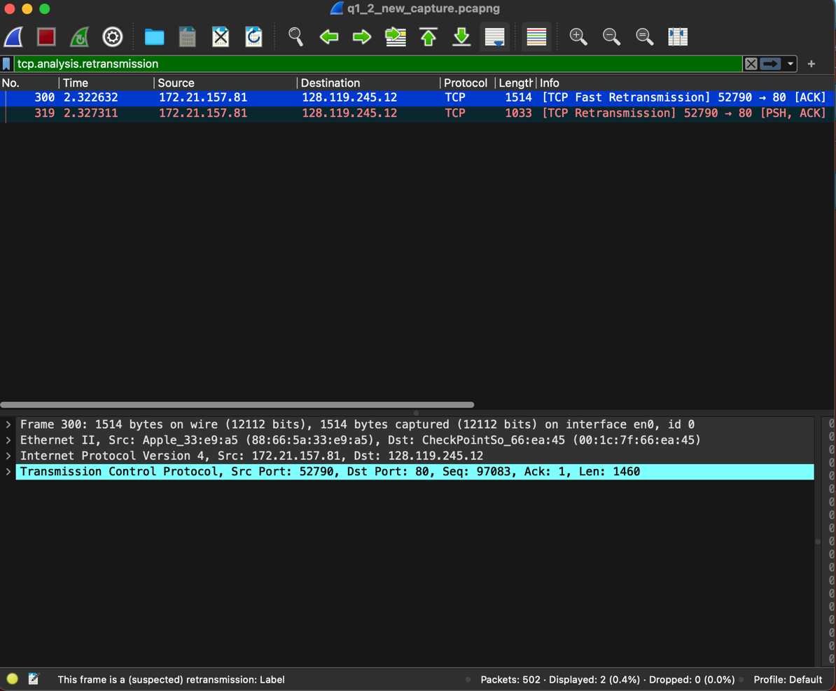

*Fig1*

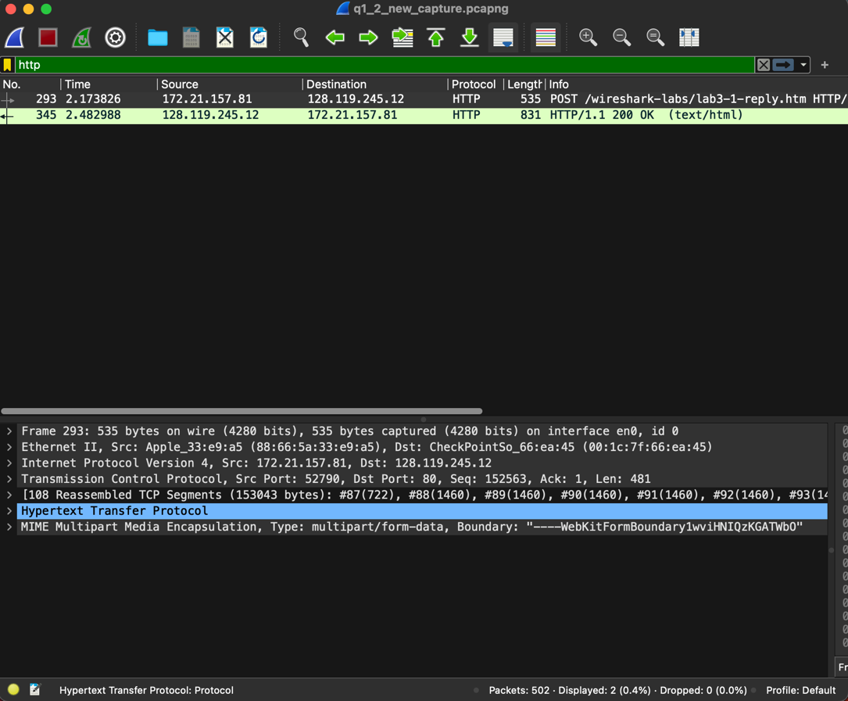

*Fig2*

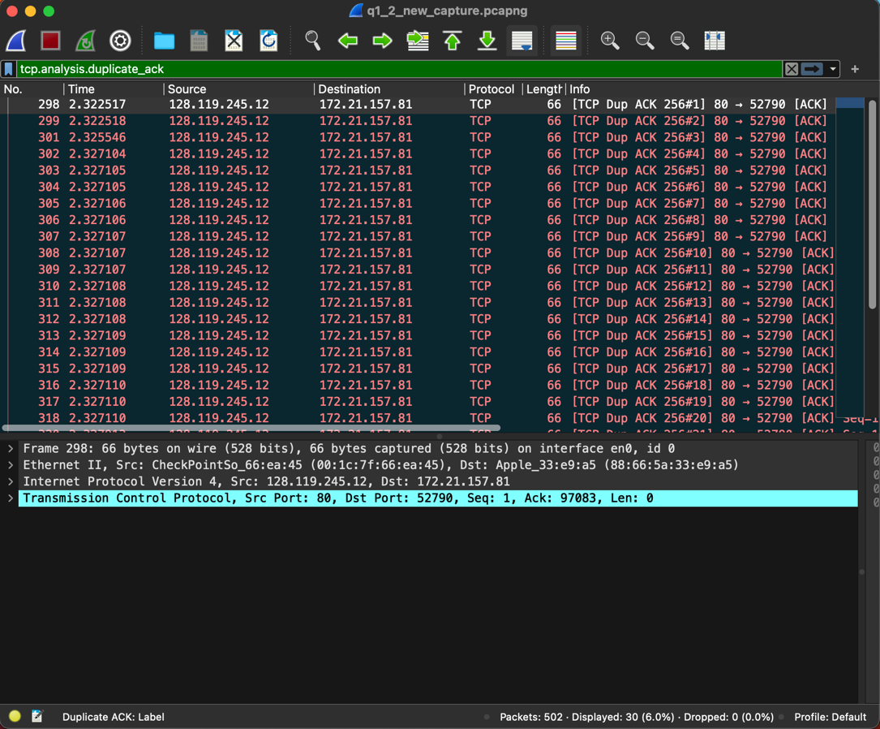

*Fig3*

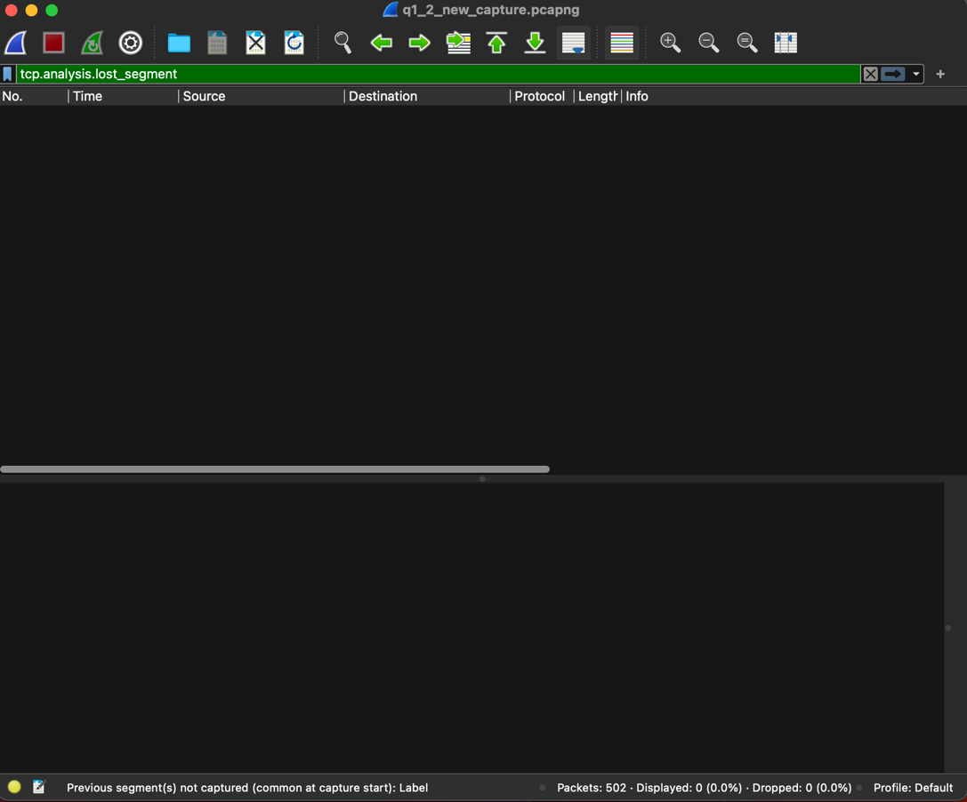

*Fig4*

1. RTT(Round-Trip Time) is time it takes for a packet to travel from its source to its destination and back for a particular TCP (Transmission Control Protocol) connection. It is a measurement of the delay or latency that data experiences during its round-trip through the network.shows how much data the recipient is willing to accept. As can be seen from the below screenshots first I filtered conversation between my port 52790 and the server 80(Using Statistics > Conversations). Then using the Statistics tab I visualized RTT graph(Using Statistics > TCP Stream Graphs > Round Trip Time). As expected RTT varies over time. The highest I found - which is the peak in the RTT graph as well – is 2.158s. There can be a lot of different reasons for that such as network congestion, routing changes, interference&noise in wireless connection etc.

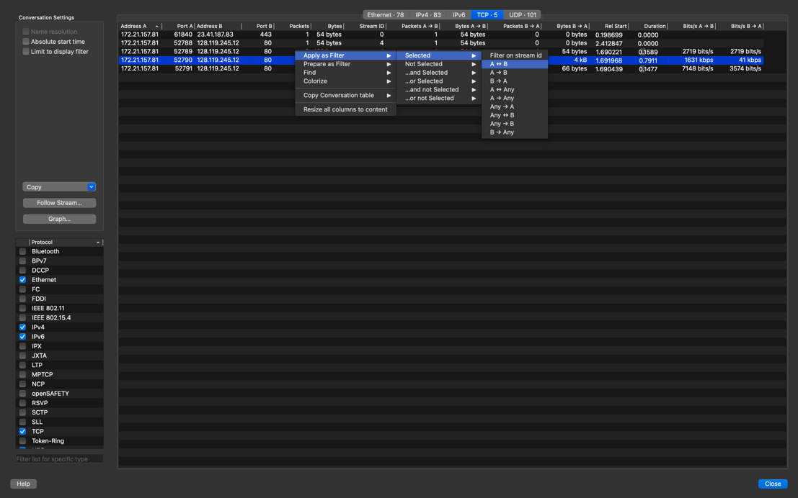

*Fig1*

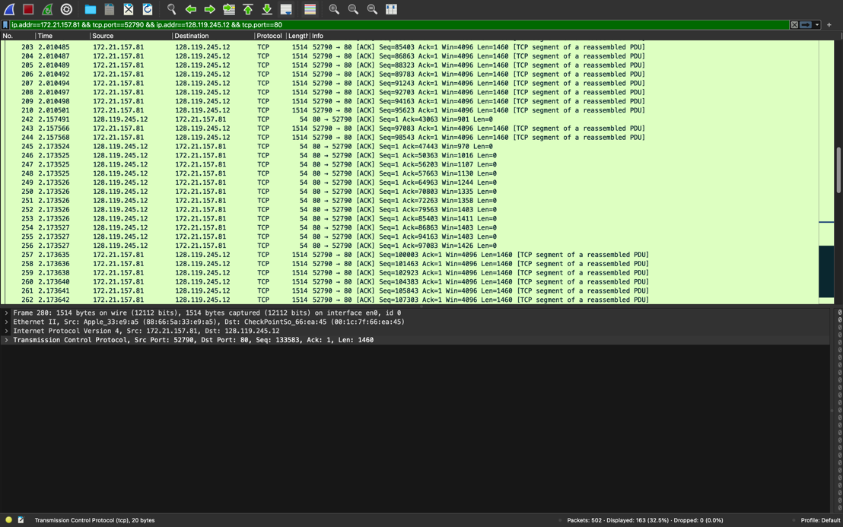

*Fig2*

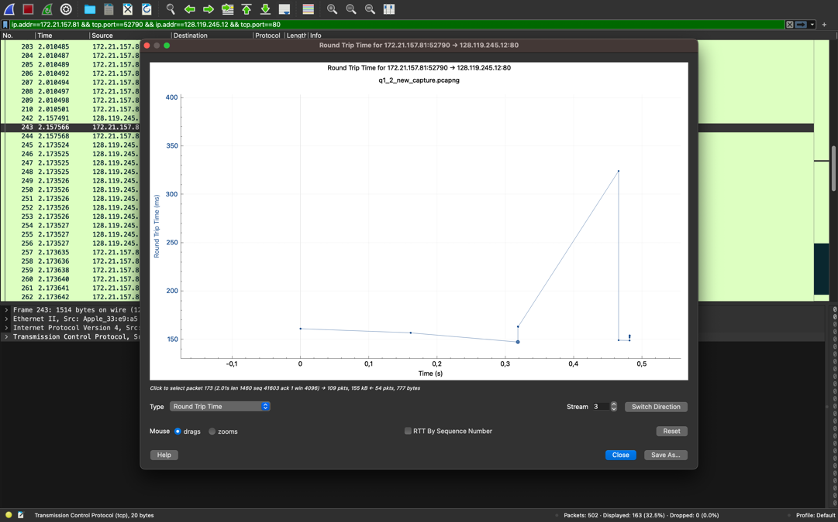

*Fig3*

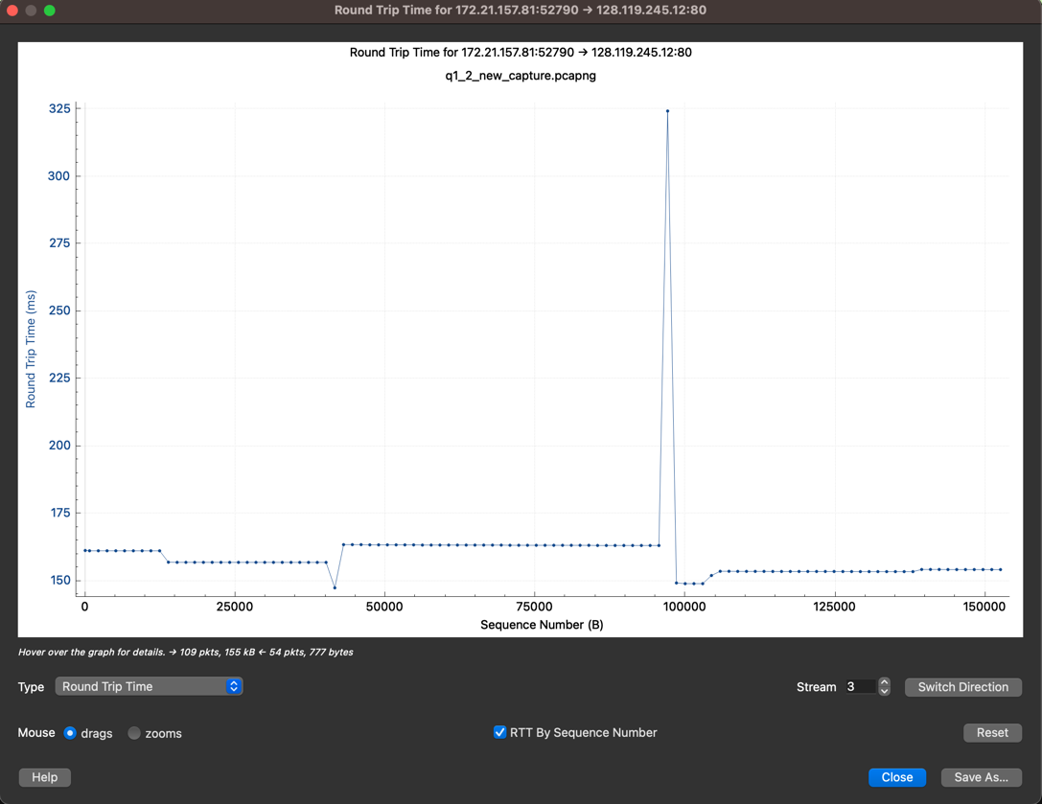

*Fig4*

1. We know that while TCP provides connection-oriented reliable transport, UDP provides connetionless transport. In addition to that TCP ensures flow & congestion control while UDP does not. To provide this kinds of features TCP header has sequence numbers, acknowledgment numbers, and flag. Those informations serves the purpose of enabling reliable, connection-oriented communication with features like error recovery, flow control, and congestion control. For example sequence numbers are used to order and reassemble segments, while acknowledgment numbers acknowledge received data. This facilitates reliable and ordered data transfer. You can see the screenhots for both UDP and TCP below.

* ACK (Acknowledge): When data is received and a connection has been established, the ACK flag is raised. It frequently appears alongside the SYN flag. To acknowledge receiving the SYN packet, for instance, the device responding to it sets the ACK flag during the three-way handshake.
* SYN(Synchronize): Two devices can establish a connection by using the SYN flag. A device sends a TCP packet to the target device with the SYN flag set when it wishes to establish a TCP connection. Handshake process starts with this.
* FIN (Finish): A TCP connection can be terminated by setting the FIN flag 1. A device sends a TCP packet with the FIN flag set when it wishes to terminate a connection.
* Window Size: As can be seen from the below screenshot window present in TCP header, indicates the amount of data that the receiver is willing to accept. This is important for flow & congestion control.

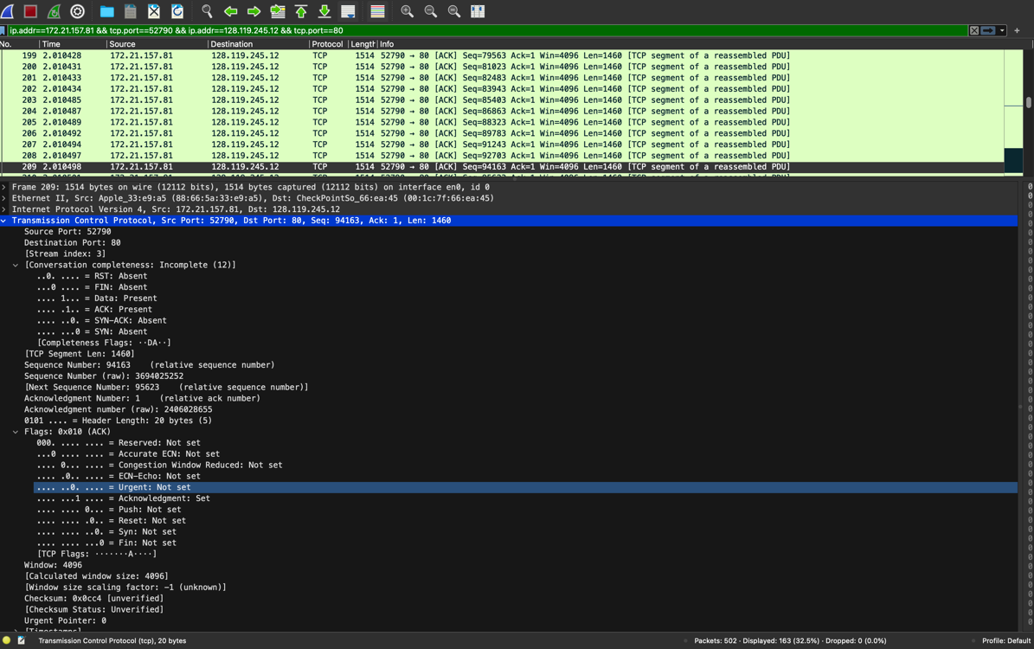

*Fig1*

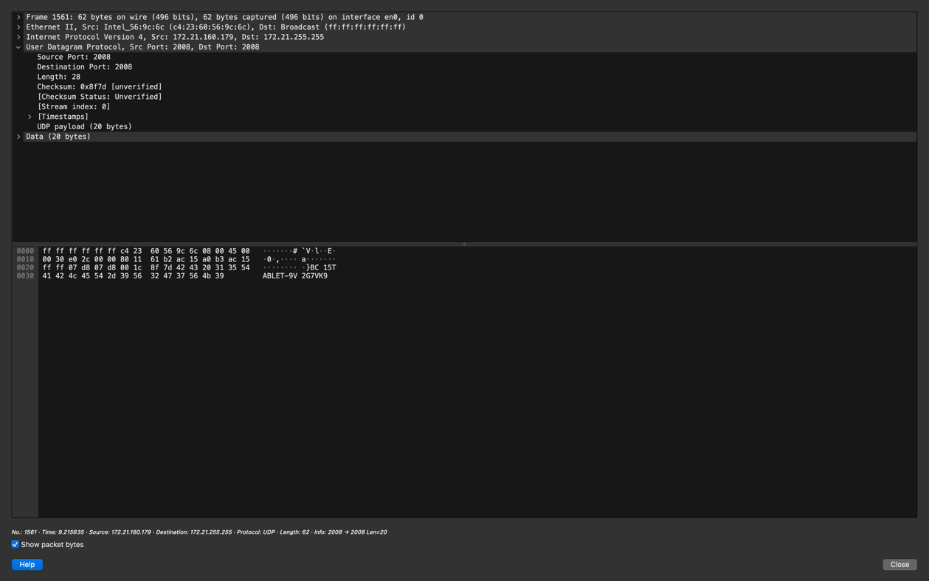

*Fig2*

1. In the screenshots below flow graphs for UDP and TCP can be seen. For both of them I included 3 screenshots. One of them is limiting to only display filter option is clicked and the other one is unclickled (which shows all of them). The third one shows only the TCP/UDP flow in the graph. First 4 screenshots for TCP and the last 4 for UDP. You can see the content of them in the 4th screenshot for each.

As can be seen below TCP diagram has PSH, ACK and connection closes with FIN,ACK at the end. The PSH flag instructs the receiving TCP stack to send the data it has received straight to the receiving application, bypassing the need to buffer additional data. While there is no ACK, FIN, PSH type of flagging in UDP since it is not reliable.

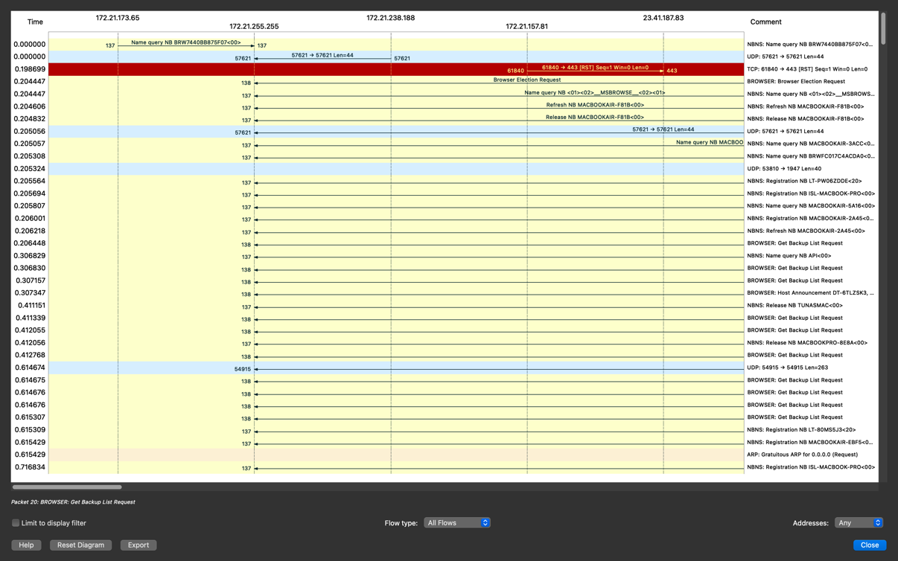

*Fig1*

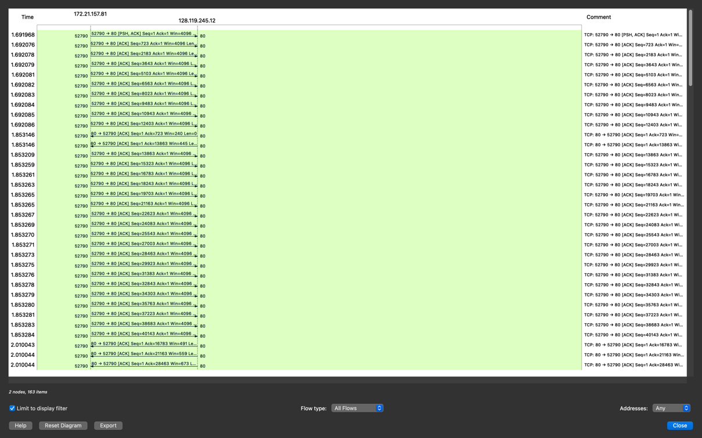

*Fig2*

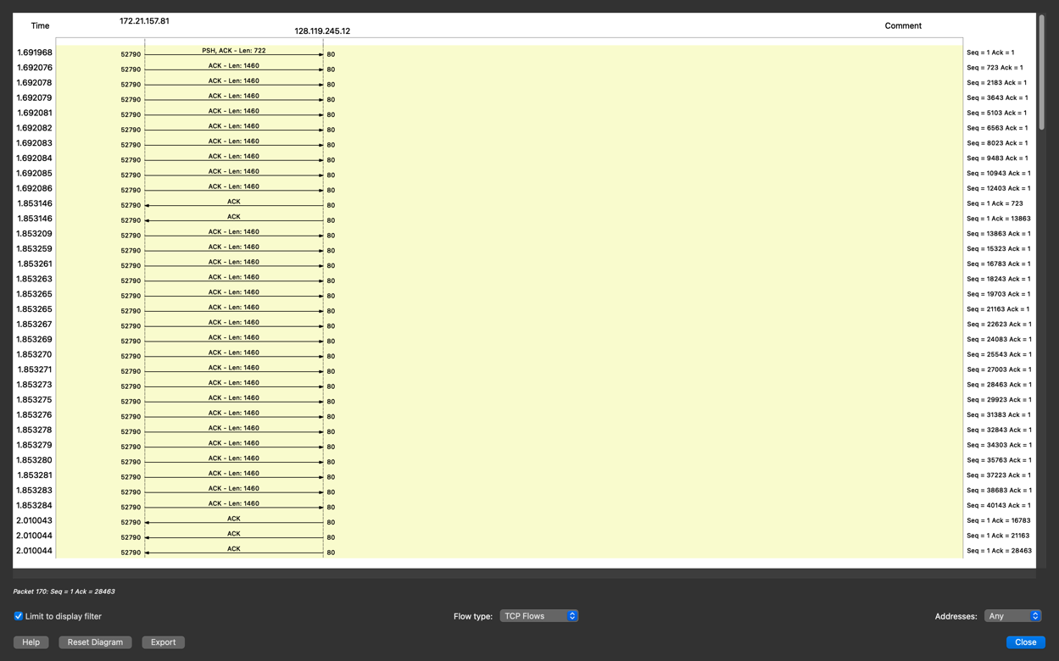

*Fig3*

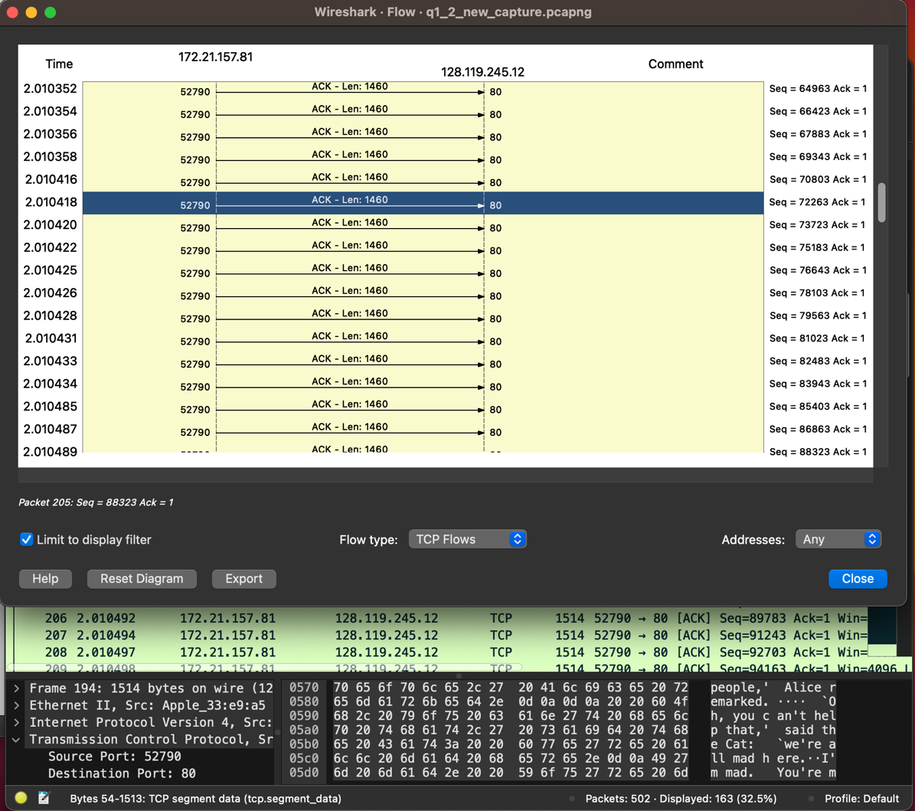

*Fig4*

**UDP:**

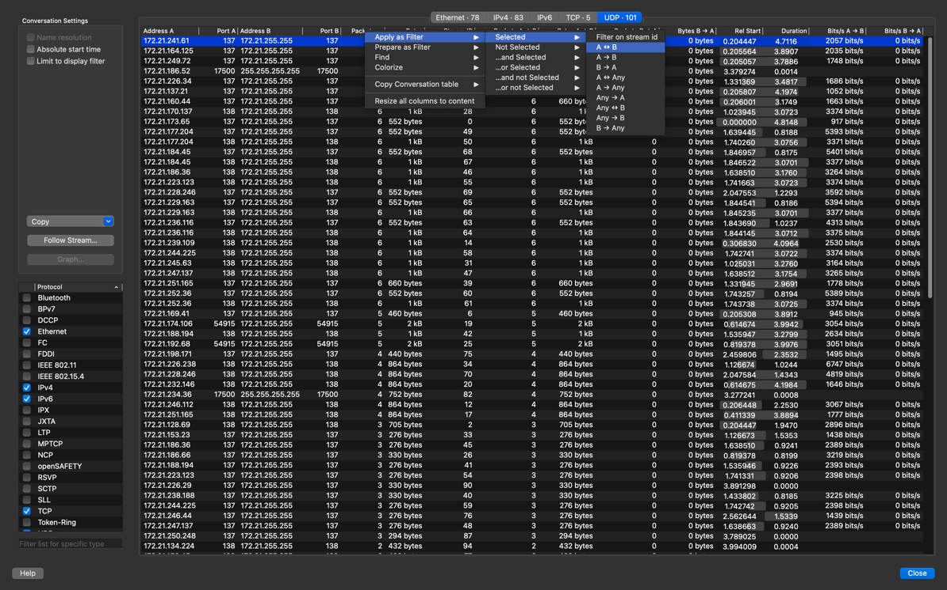

*Fig1*

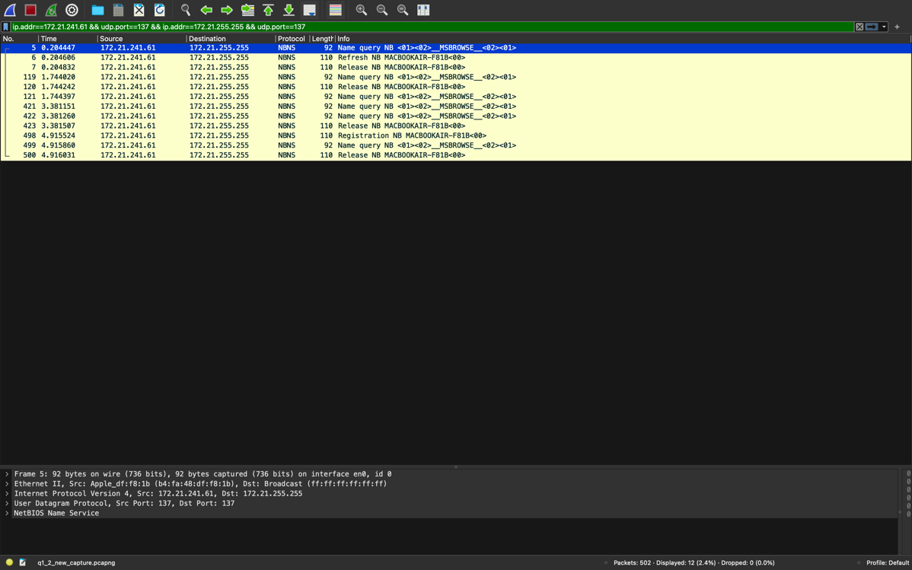

*Fig2*

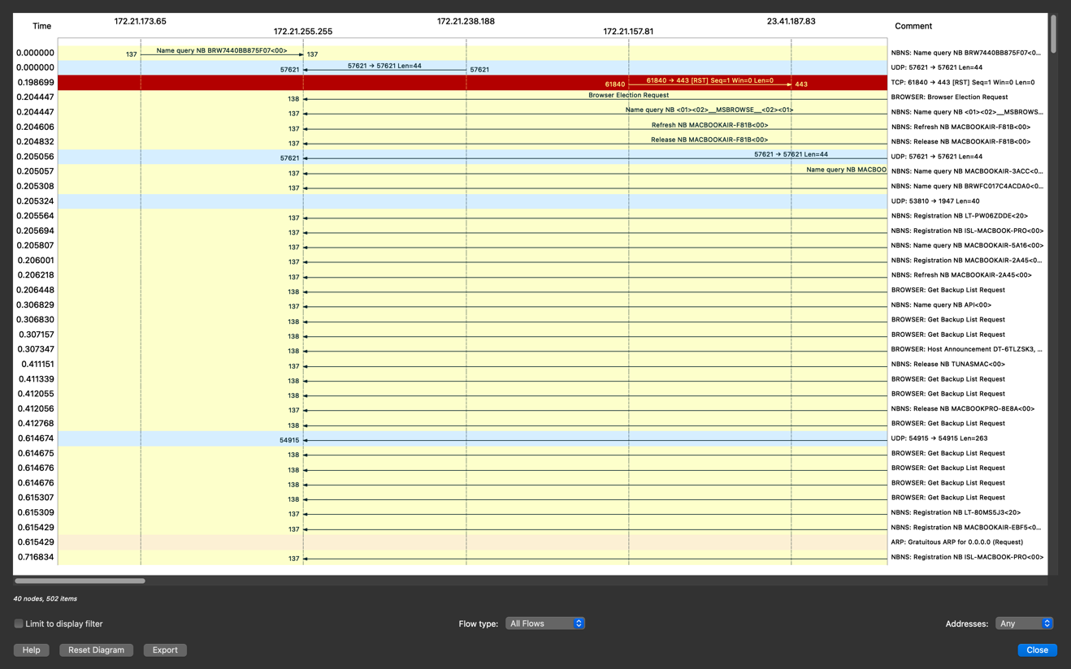

*Fig3*

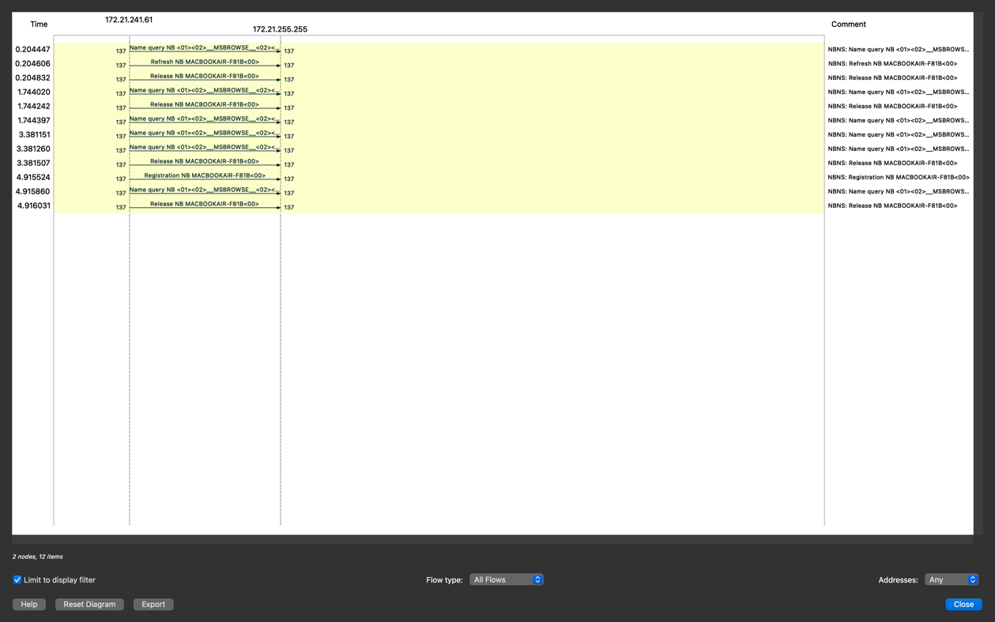

*Fig4*

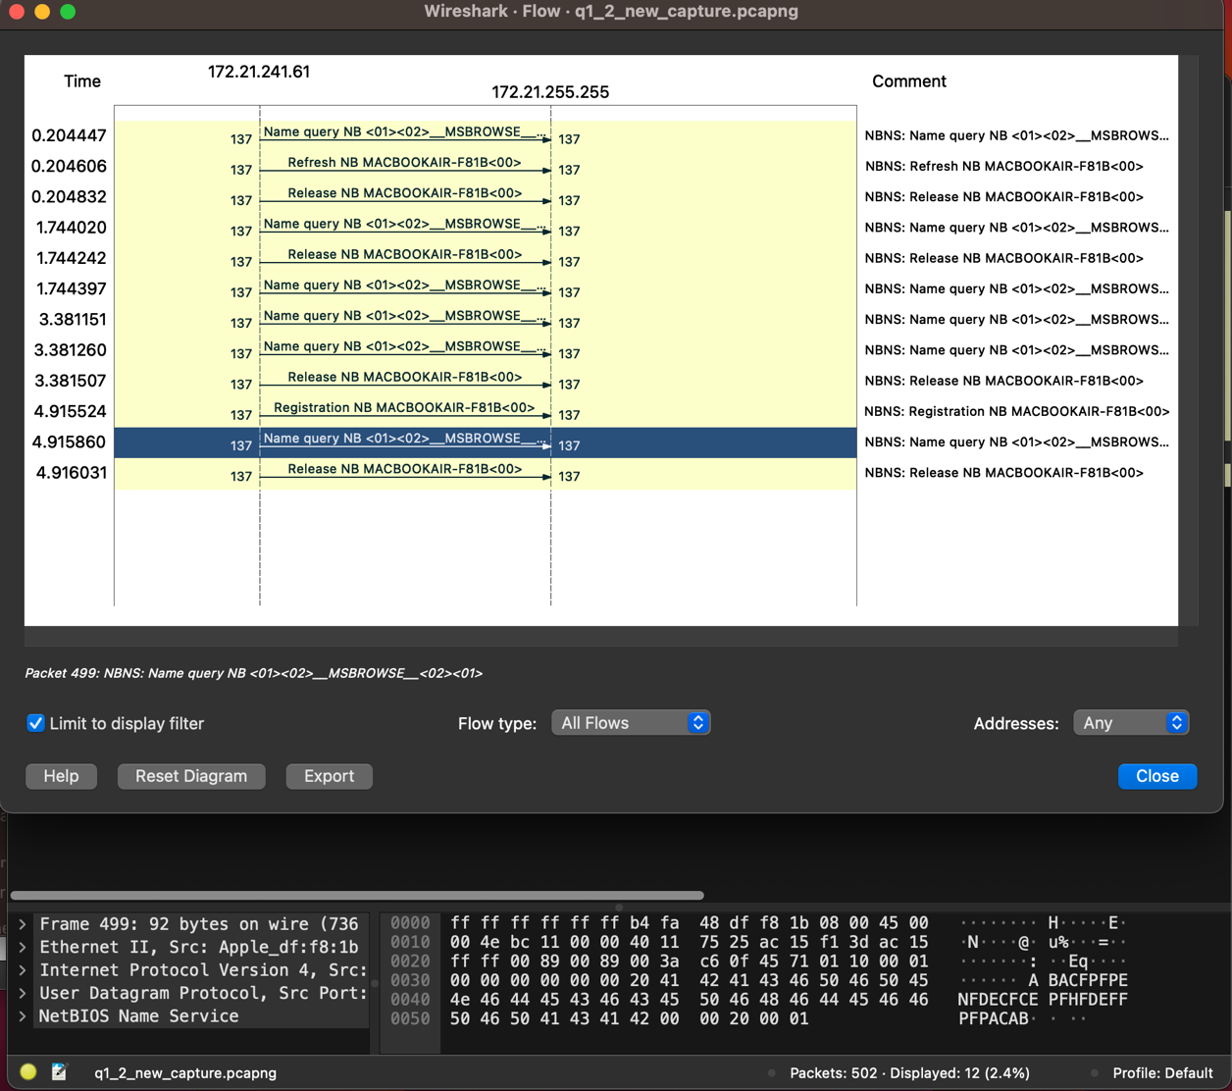

*Fig5*

**Question 2.1**

1. In my implementation there are 2 types of client. I mean based on the choice of client I initialize a class either TCP or SSL. While TCP client uses TCP, SSL Client uses TLS in addition to TCP which provides security by encoding the message. In the below screenshots you can see the process and outputs step by step.

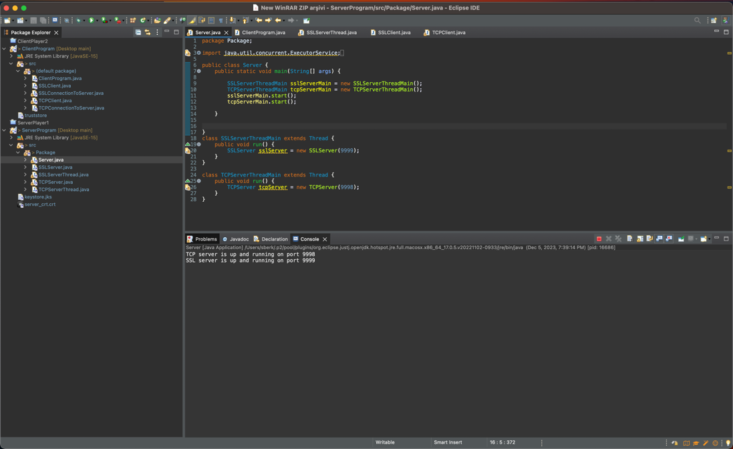

*Fig1*

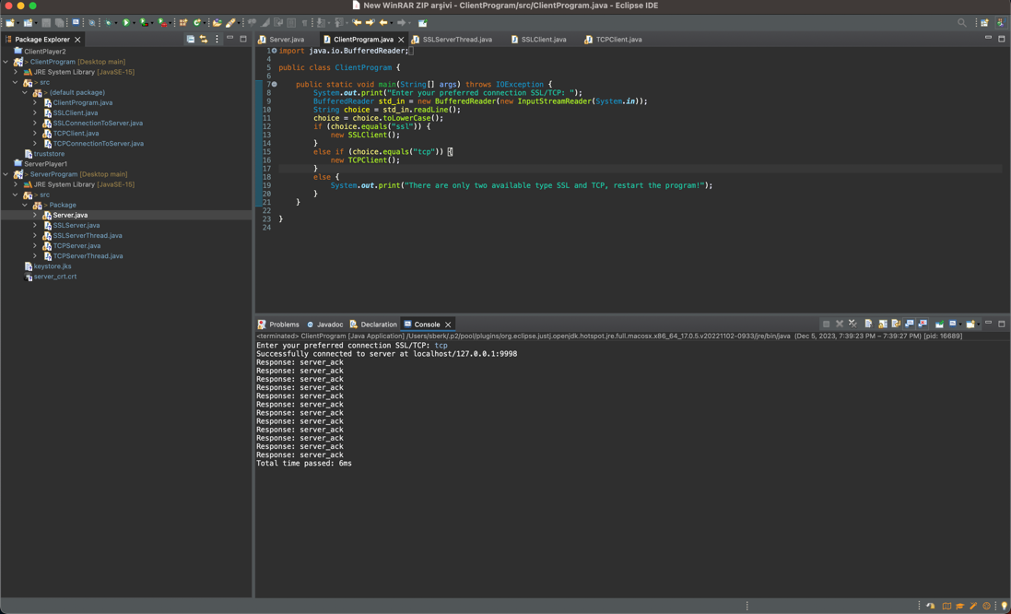

*Fig2*

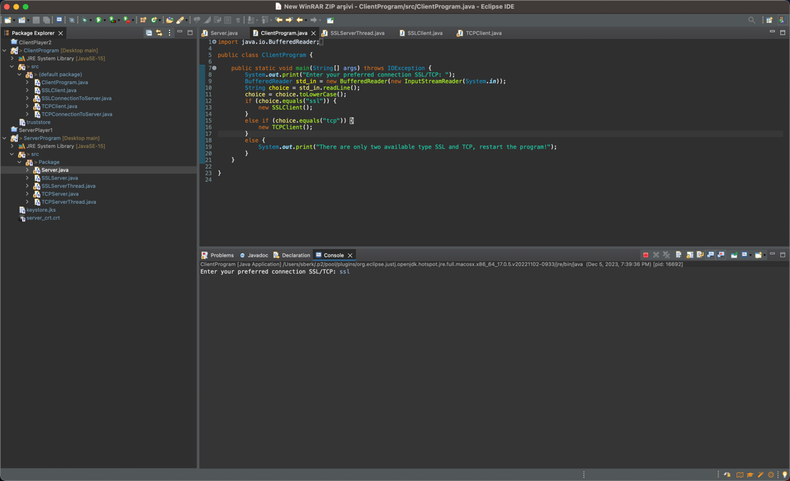

*Fig3*

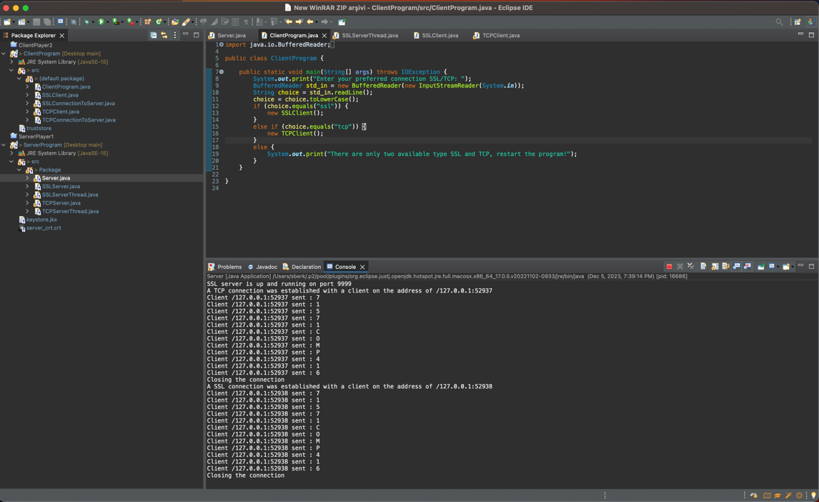

*Fig4*

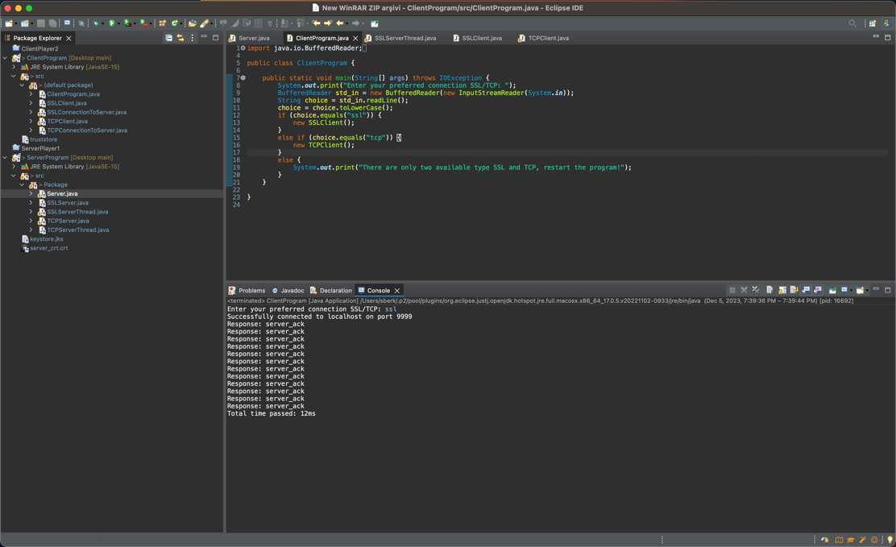

*Fig5*

1. In the screenshot below you can see the data from each connection. In TLS protocol since it is encrypted/secured we cannot understand(look at the first ss) while in TCP(no encryption) we can easily see and the read content. In TCP I look for the PSH flag since it contains the data in it. Screenshots from 2-5 shows some of the content that was send back and forth between TCP client and server. To see the data please look right bottom of the screenshots. Please also be aware that not all of the text is actual data it contains TCP header info, flags, window size etc. in Wireshark screenshots that I take, data is at the end.

* In the 2nd screenshot “server_ack” message that we sent is seen.
* In the third “7” seen. Which is included in my school number 71571.
* In the fourth “C” is seen. Which was included in our message.
* In the fifth “6” is seen 2 PSH before the FIN flag which denotes the end of conversation. The PSH right before the FIN flag is “server_ack” message.

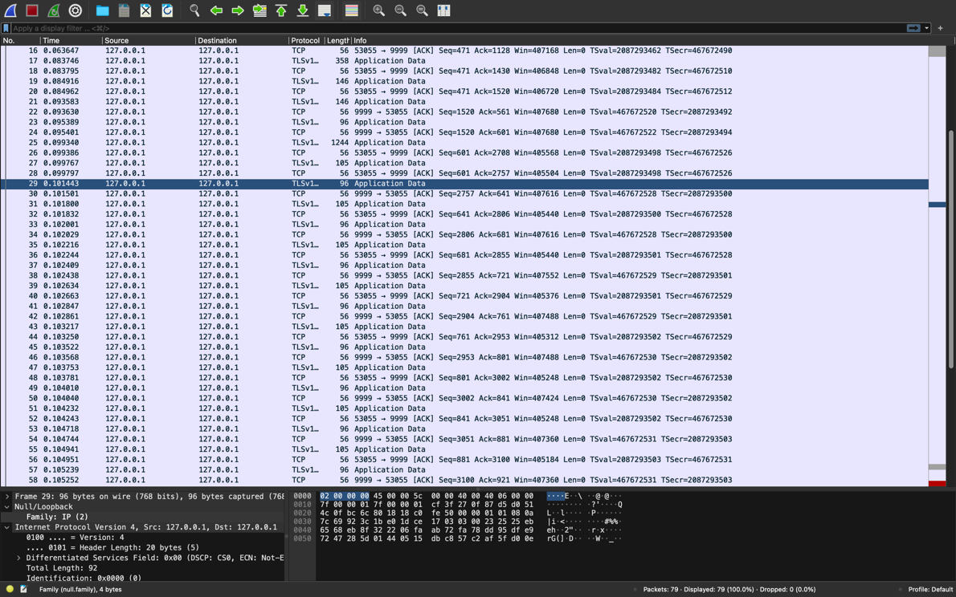

*Fig1*

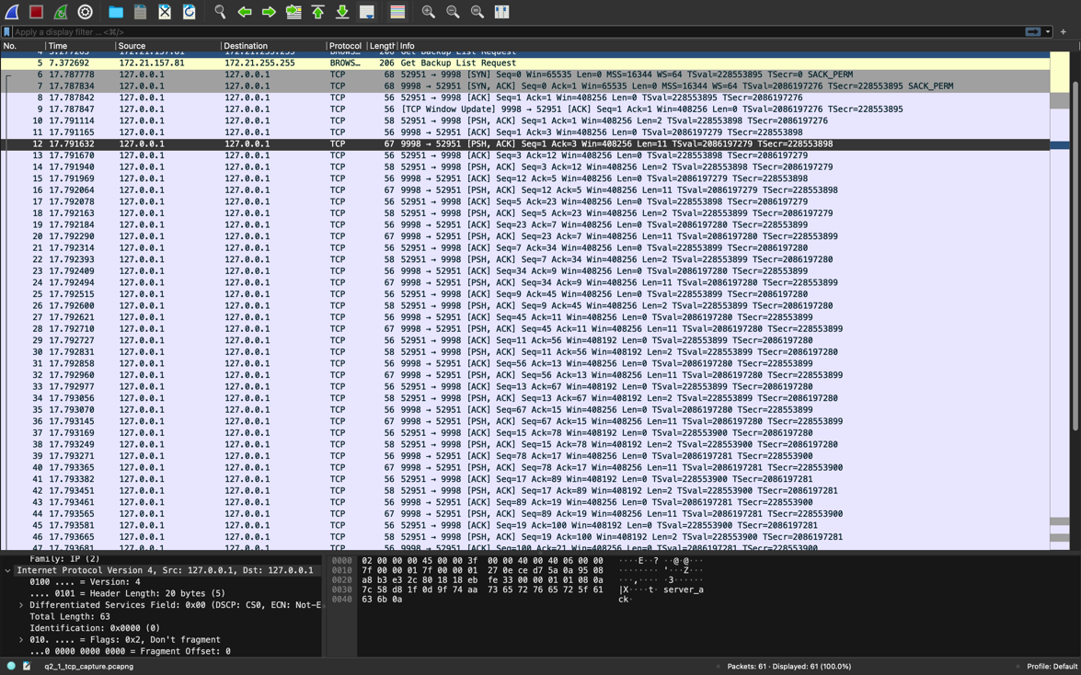

*Fig1*

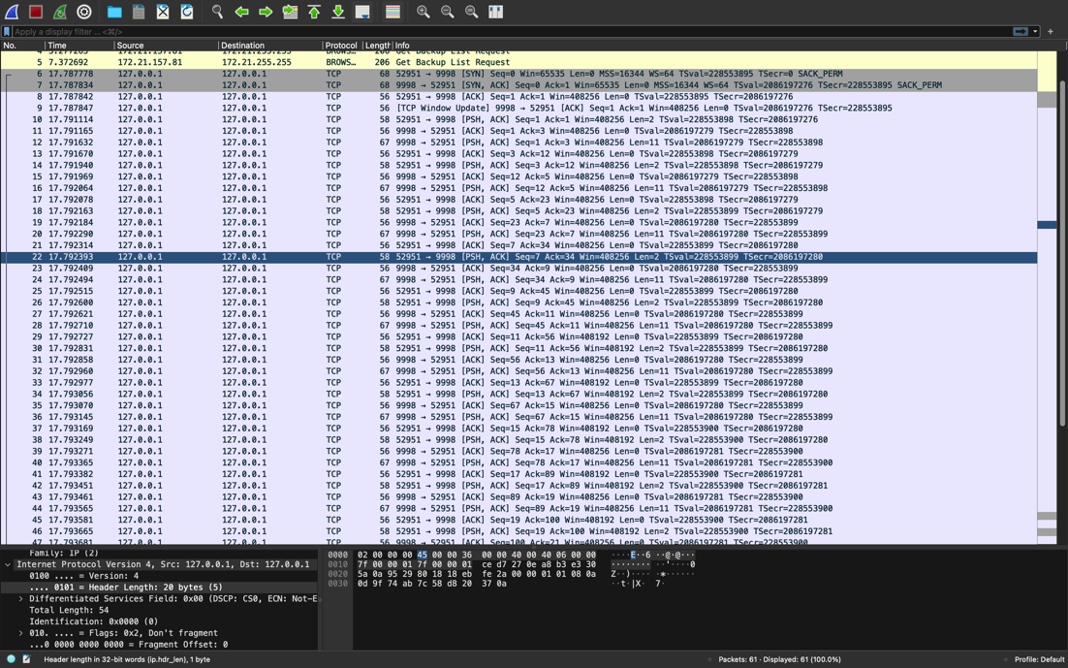

*Fig2*

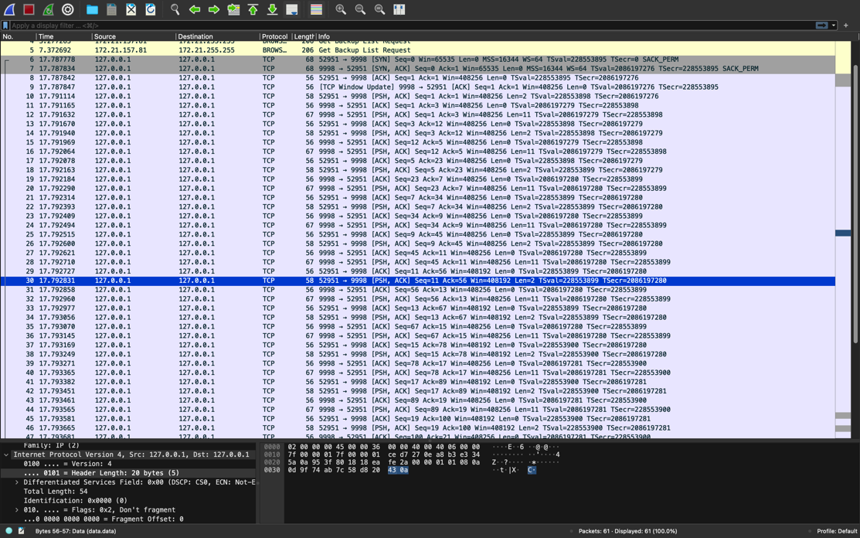

*Fig3*

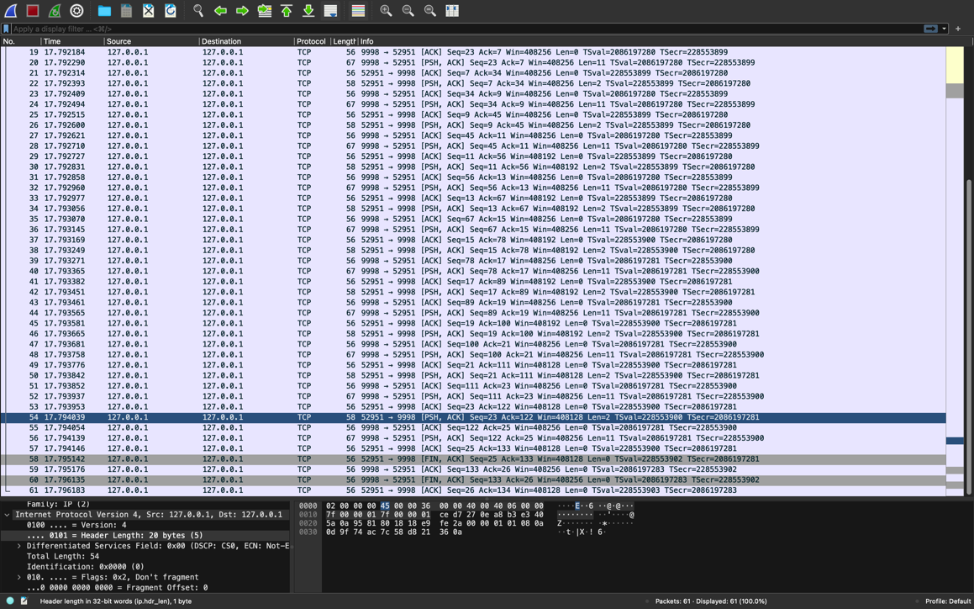

*Fig4*

1. From the above screenshots in TCP since it is not encrpyted we can read the content of the data easily and understand what is the message. However, since server does not send the data it received from the client to the client we cannot see inside the response message of a server. Inside the response message of a server we can only see server_ack. In TLS we cannot see none of them. S

Since we designed to send the text “71571COMP416” character by character in each packet, we can read the one character from the message in each packet that includes PSH flag. As can be seen from the first 2 screenshots two packet that includes PSH sent from client to the server includes “7” and “1” respectively. My school id starting with “71”. While in TLS we cannot see the content since it is encrypted and we could not see PSH flag.

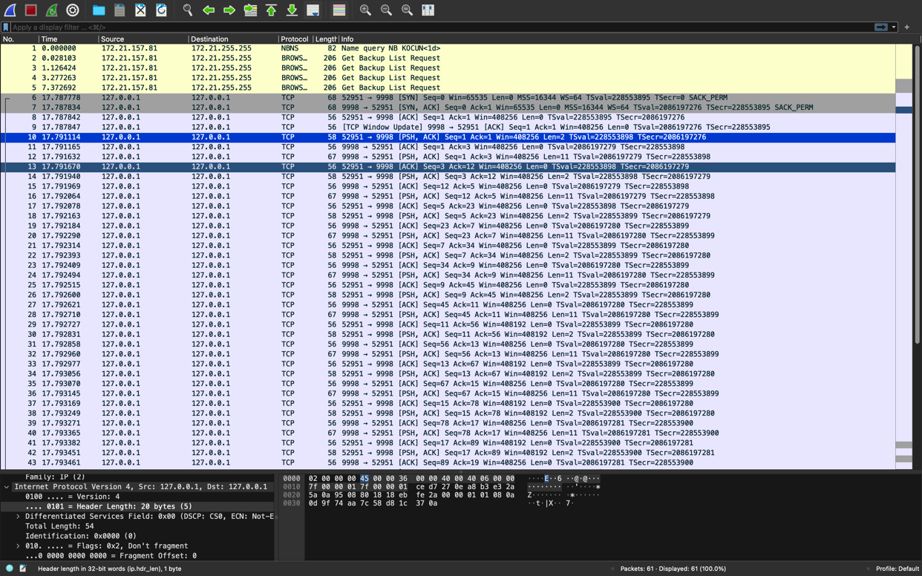

*Fig1*

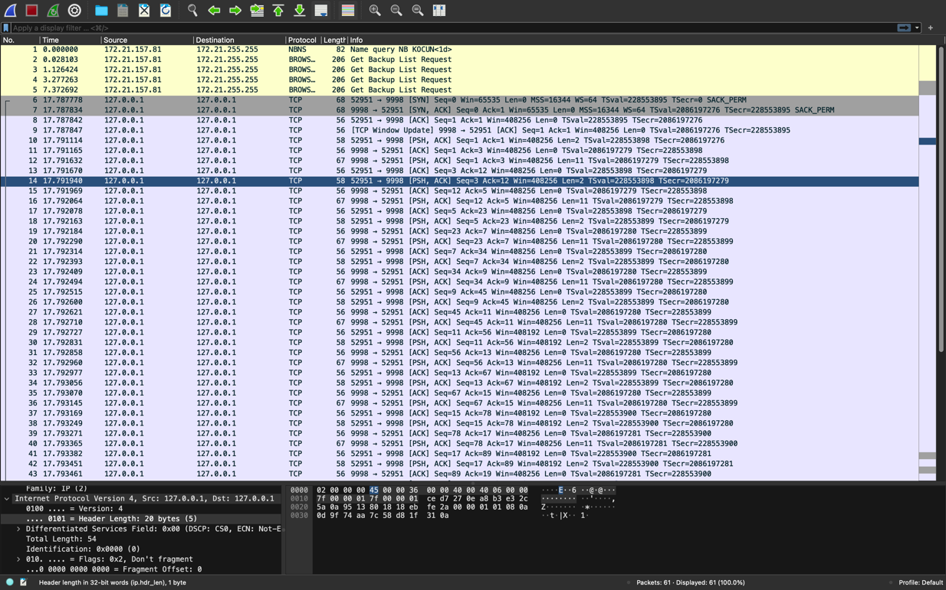

*Fig2*

1. Below in the screenshots you can see the results of 5 executions for both TCP and SSL. Graph is in the below as well. As expected SSL takes more time since encryption process takes time.

**TCP Results: 4-4-5-4-4 = 23/5 => 4.6**

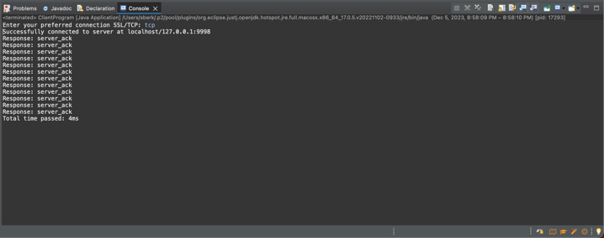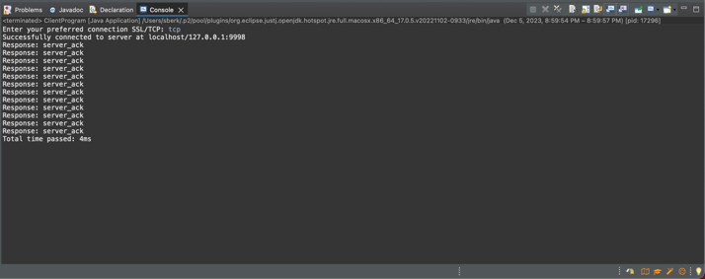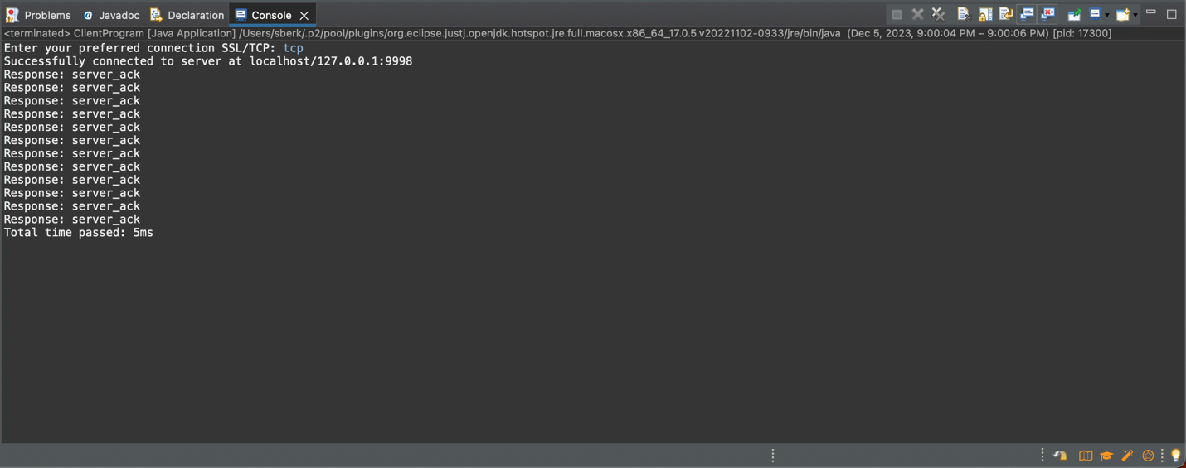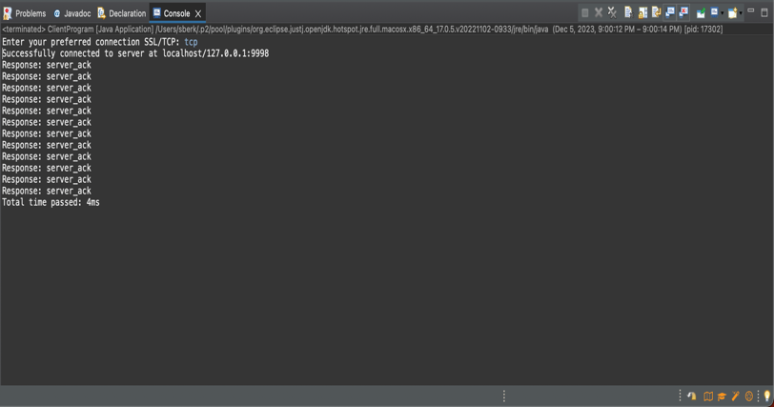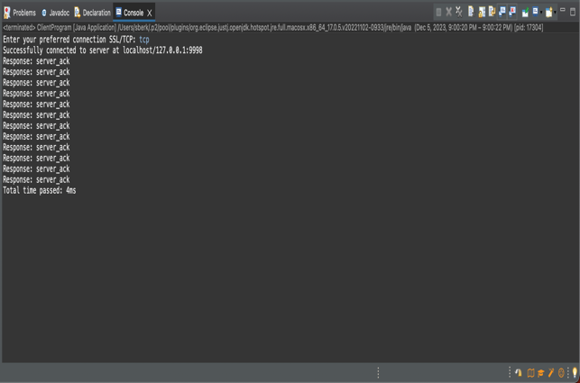

**TLS Results: 14-11-9-9-9 => 52/5=10.4**

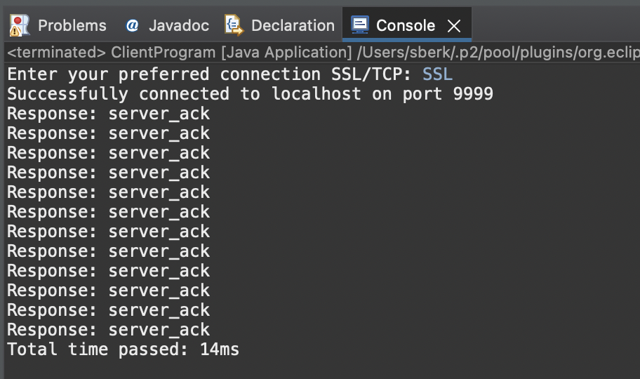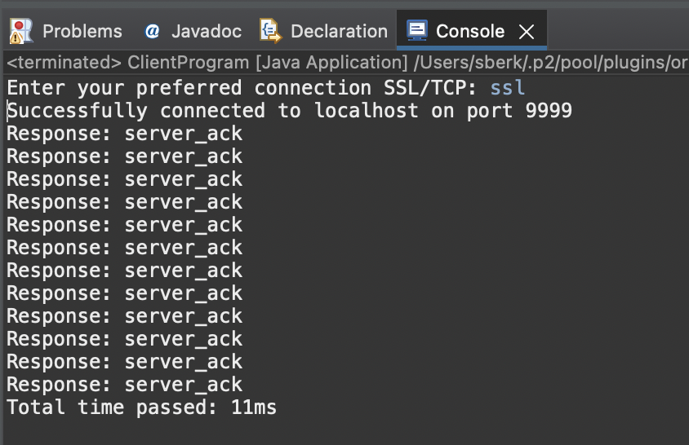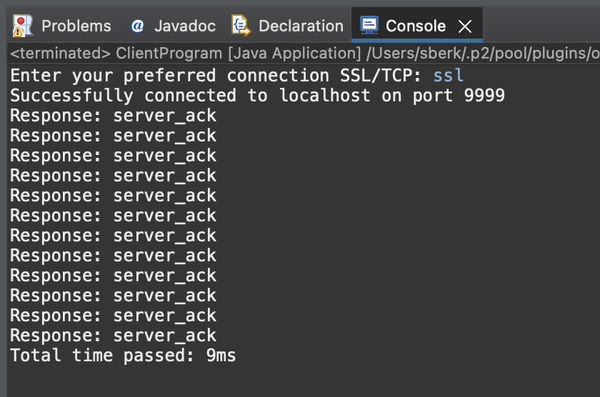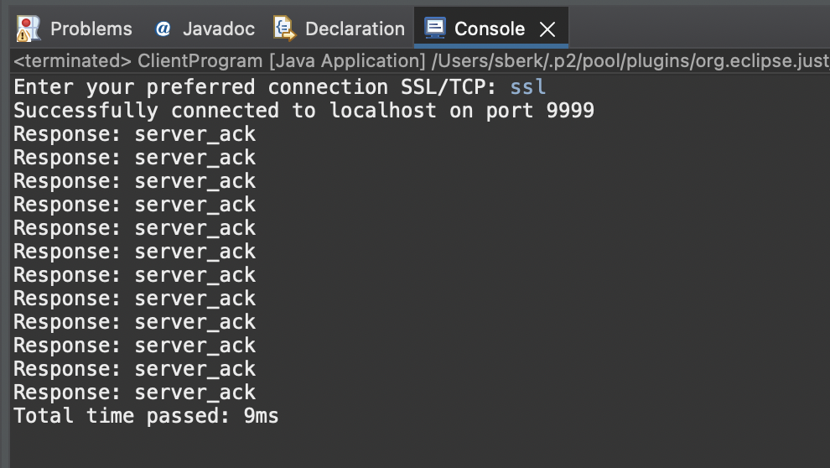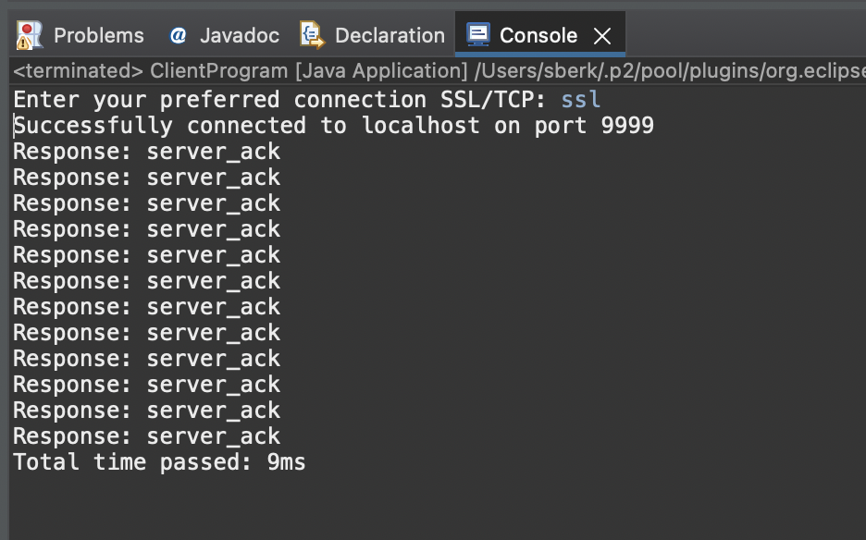

1. Client Hello and Server Hello packets are used for TCL handshake purpose. They are not present in TCP. As can be seen from the below screenshots they are Handshake Protocols. First with Client Hello packet client requests server a secure connection. It includes fields like sessionId, cipher suites, TLS version etc. At the end of handshaking process both parties agree on symmetric secret key.

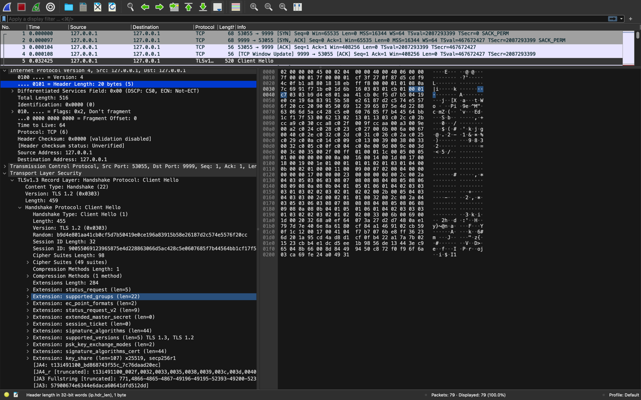

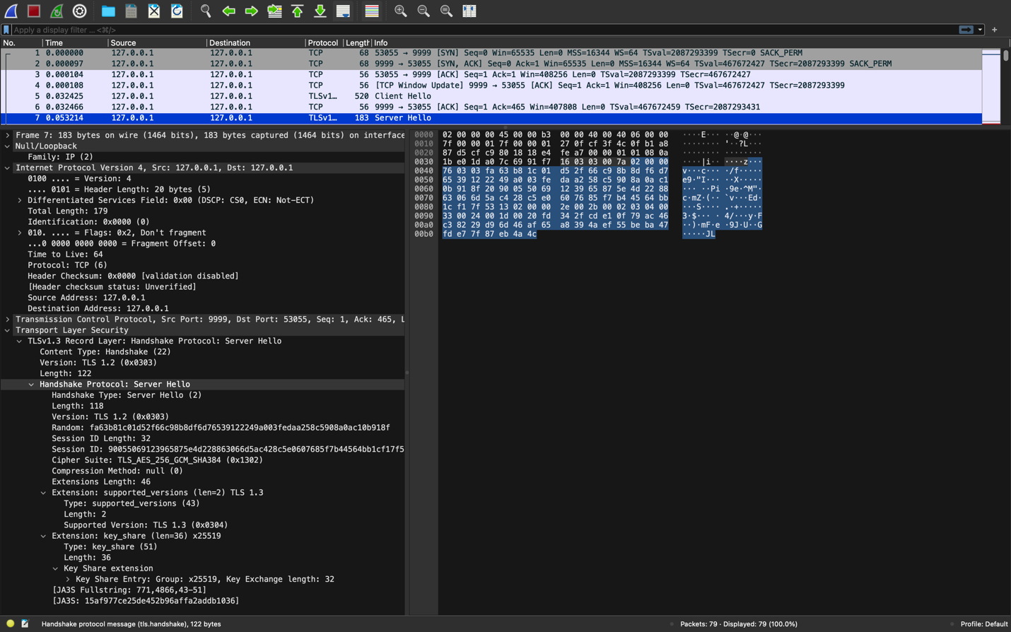

1. Certificates and cryptographic parameters are important components of TLS. The extra overhead and latency involved in repeatedly transmitting the certificate would make it inefficient to send the certificate for every connection. To overcome this issue session resumption feature -which avoids sending the certificate for each connection- is used. After the establishment of secure connection the server generates unique session identifier and sends it to the client. The client includes the session ID that was previously negotiated in its Client Hello message in subsequent connections. After receiving the session data, the server determines whether it has the associated session state saved. The server can quickly reestablish the connection with the previously set cryptographic parameters if it discovers a matching session. As can be seen in the below *Figure 1.* Client Hello message includes session id in it.

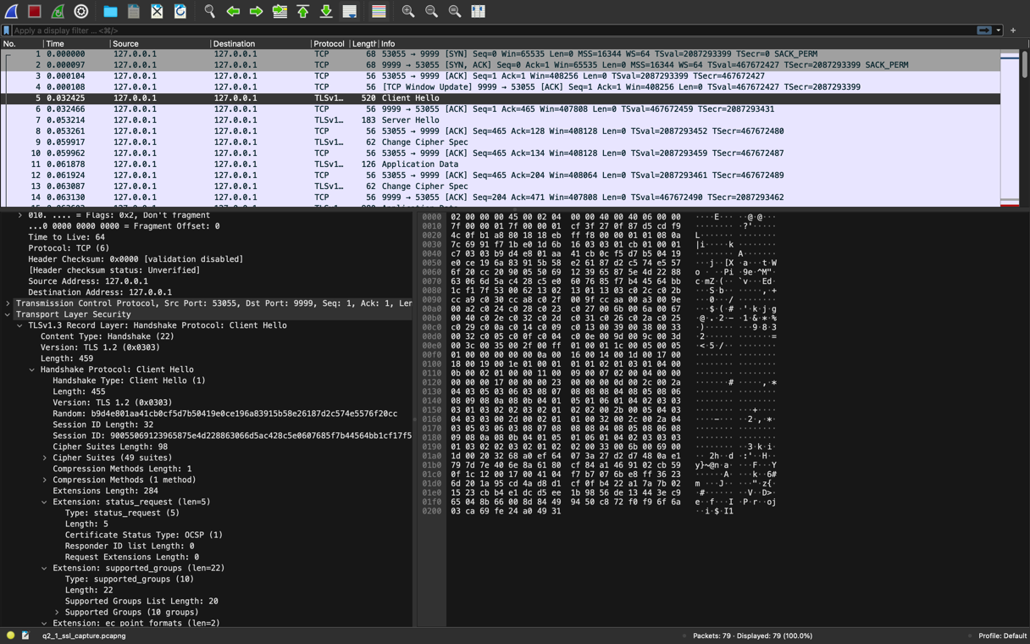

**Question 2.2**

Screenshots for my keystore can be seen in below. The passwords I used is as following **serkan12345.** and **changeit** for -storepass.

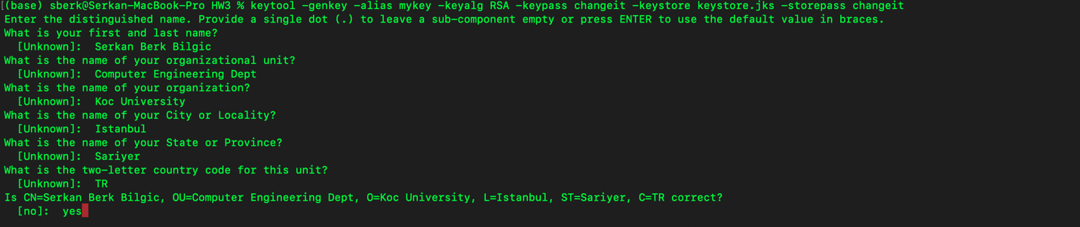

*Fig1*

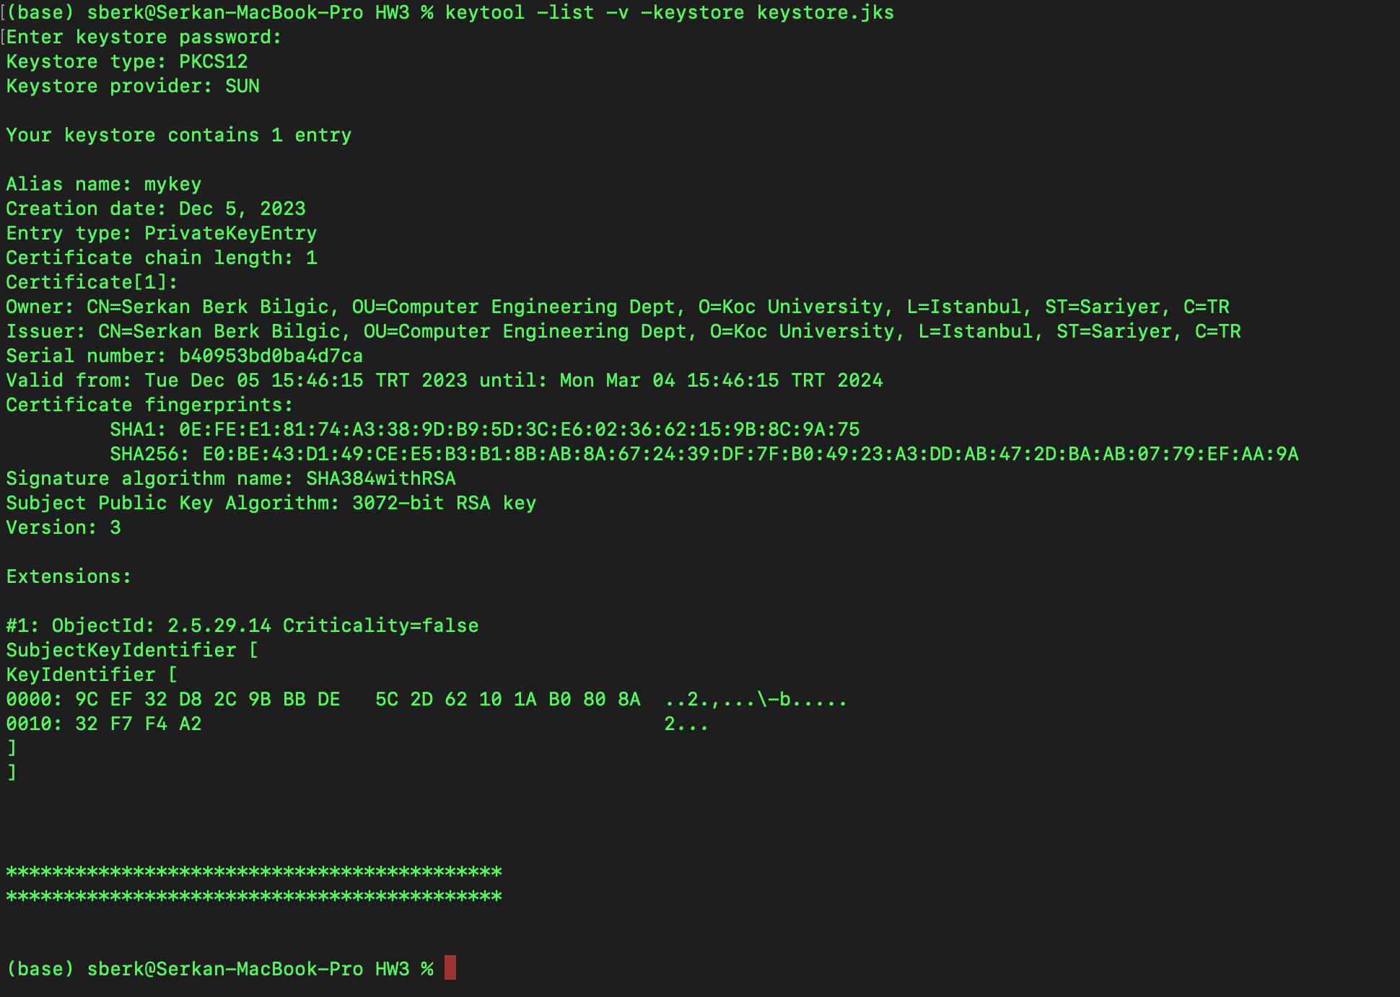

*Fig2*

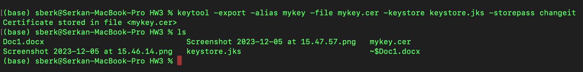

*Fig3*

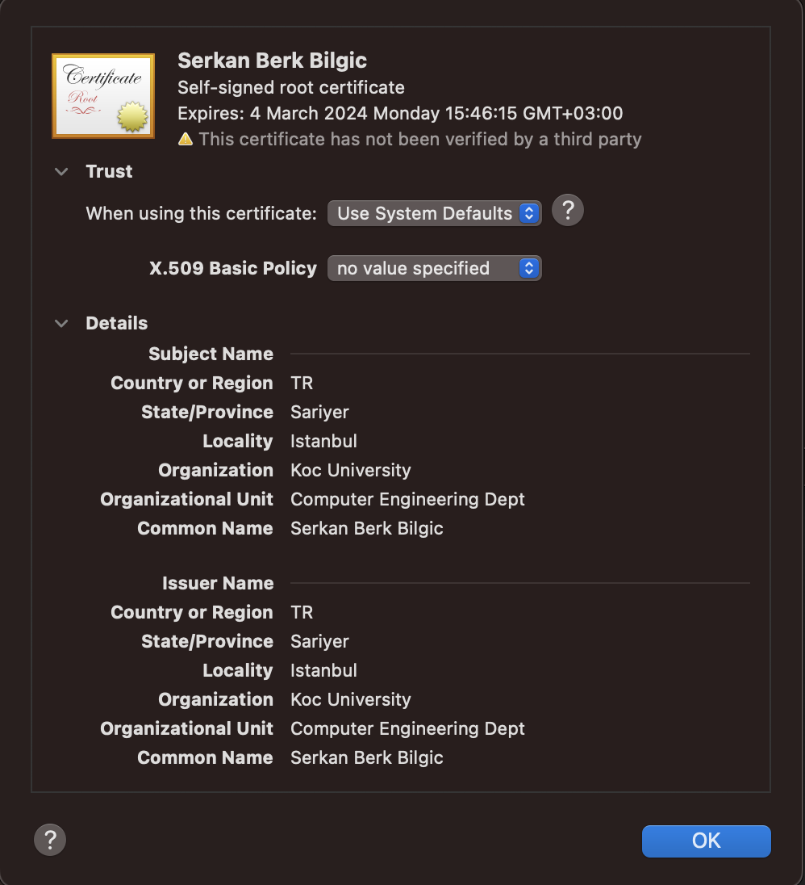

*Fig4*

**Trust Store Part:**

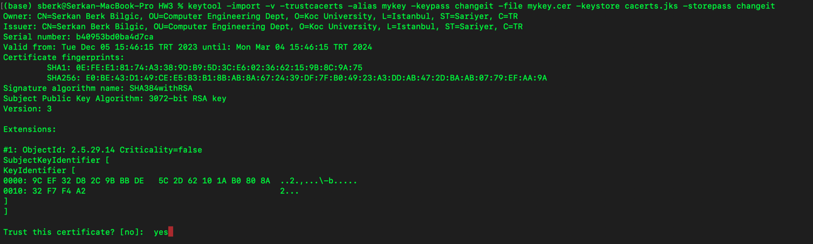

*Fig1*

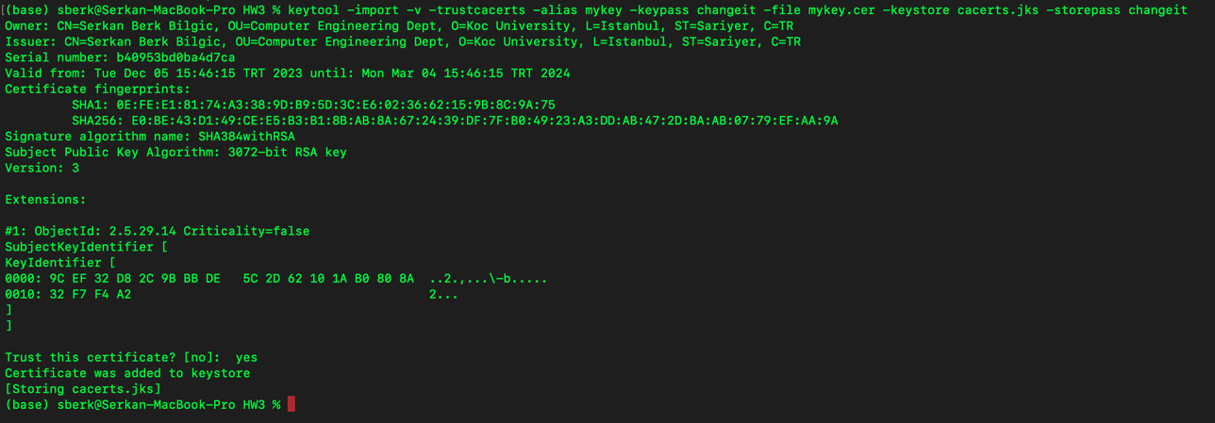

*Fig2*



*Fig3*

